|  |
| --- |
| Close-up image showing the leaf-sides of two oversized books side-by-side on a bookshelf, with additional books in soft focus background |
| BUSINESS ANALYTICS  **GROUP T** |
| |  |  |  | | --- | --- | --- | | **(pg) Daniel Adeleke** | **12/14/23** | **MATH525** | |

**Table of Contents**

**INTRODUCTION AND COMPANY PROFILE** 4

**Introduction** 4

**Company Profiles** 4

**AIM OF THE REPORT** 10

**ANALYSIS OF FINANCIAL STATEMENTS** 17

**Horizontal and Vertical Analysis** 17

**Ratio Analysis** 22

LIQUIDITY 22

PROFITABILITY 23

EFFICIENCY 25

SOLVENCY 27

FINANCIAL GEARING 28

OPERATIONAL 29

**ANALYSIS OF MARKET DATA** 31

**Recommendations & Conclusion** 38

**APPENDICES** 41

**List of aggregations to fit the Balance Sheet template** 41

**List of aggregations to fit the Income Statement template** 42

**Airtel Africa Aggregated Balance Sheet** 43

**Vodafone Group Aggregated Balance Sheet** 44

**Airtel Africa and Vodafone Group Aggregated Income Statement** 45

**Calculations of Two Additional Ratios** 46

**REFLECTIVE REPORTS** 47

**10892938** 47

**10764009** 48

**10892109** 49

**10887206** 50

**References** 51

**Table of Figures**

**Figure 1: Assets and Liabilities for Airtel Africa** 5

**Figure 2: Revenue and Expenses for Airtel Africa** 6

**Figure 3: Assets and Liabilities for Vodafone Group** 8

**Figure 4: Revenues and Expenses for Vodafone Group** 9

**Figure 5: Capital Asset Pricing Model (CAPM)** 32

**Figure 6: CAPM FOR SOME UKSTOCKS** 34

**Figure 7: Portfolio Analytics Graph of UKSTOCKS** 35

**Figure 8: Cumulative Returns of UKSTOCKS** 36

**Figure 9: Log Return for Airtel Africa** 37

**Figure 10: Log Return for Vodafone Group** 37

# **INTRODUCTION AND COMPANY PROFILE**

## **Introduction**

The telecommunications sector is made up of companies that facilitate communication on a global scale, using various means such as phone networks, internet, airwaves, and cables. “These companies build and maintain the infrastructure that enables the transmission of data (such as text, voice, audio, or video) to any location around the world” *(DOS, 2023)*. Beers states, “the most prominent companies in the sector are telephone operators (wired and wireless), satellite companies, cable companies, and internet service providers” *(Beers, 2023)*. “The Internet has continuously evolved since its beginnings in the late 1960s, becoming the largest globally recognized communication system with advancements in technology, capacity, availability, and size” *(Mueller, 2014)*. Information is transported via packets without differentiating between individual application characteristics over manifold access and core network technologies. Classical telecommunication networks initially transport voice over circuit-switched networks before adapting packet transport to the underlying network to increase overall network performance *(Bertin, Crespi and Magedanz, 2013)*.

## **Company Profiles**

Airtel Africa Plc and its subsidiaries, as stated in Yahoo Finance, offers telecommunications and mobile money services in Nigeria, East Africa, and Francophone Africa *(Yahoo Finance, 2023)*. They provide prepaid and postpaid wireless voice, international roaming, and fixed-line telephone services, as well as data communication services for 2G, 3G, and 4G networks. Airtel Africa also offers mobile money services, including digital wallet payment systems, microloans, savings, and international money transfers. The company provides messaging, value-added, enterprise, and infrastructure-sharing services and support services. Additionally, it is involved in investment activities. Yahoo Finance states "the company was established in 2018 and is headquartered in London, United Kingdom. Airtel Africa Plc is a subsidiary of Airtel Africa Mauritius Limited" *(Yahoo Finance, 2023)*.

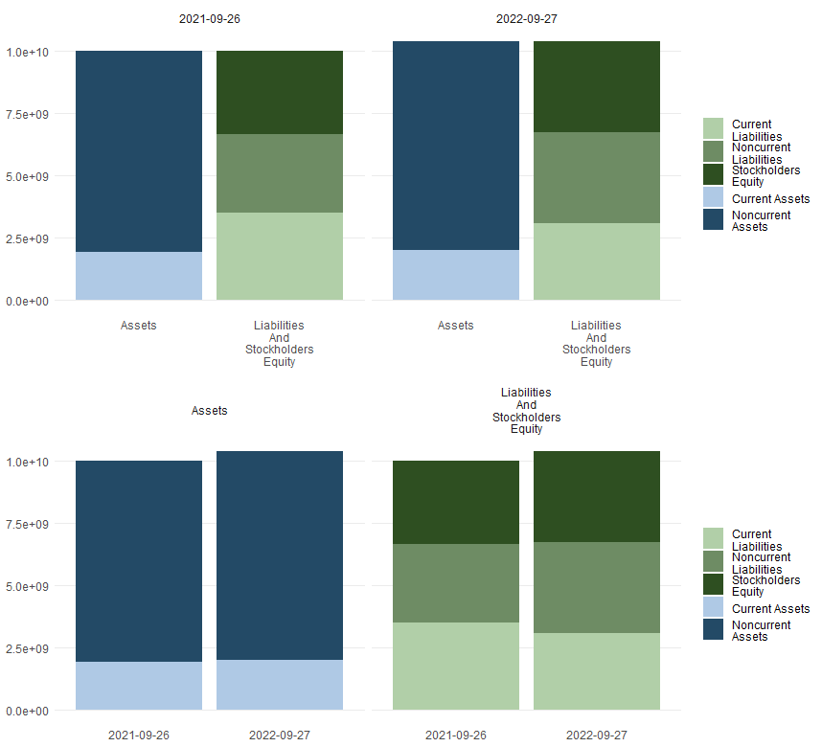

**Figure 1: Assets and Liabilities for Airtel Africa**

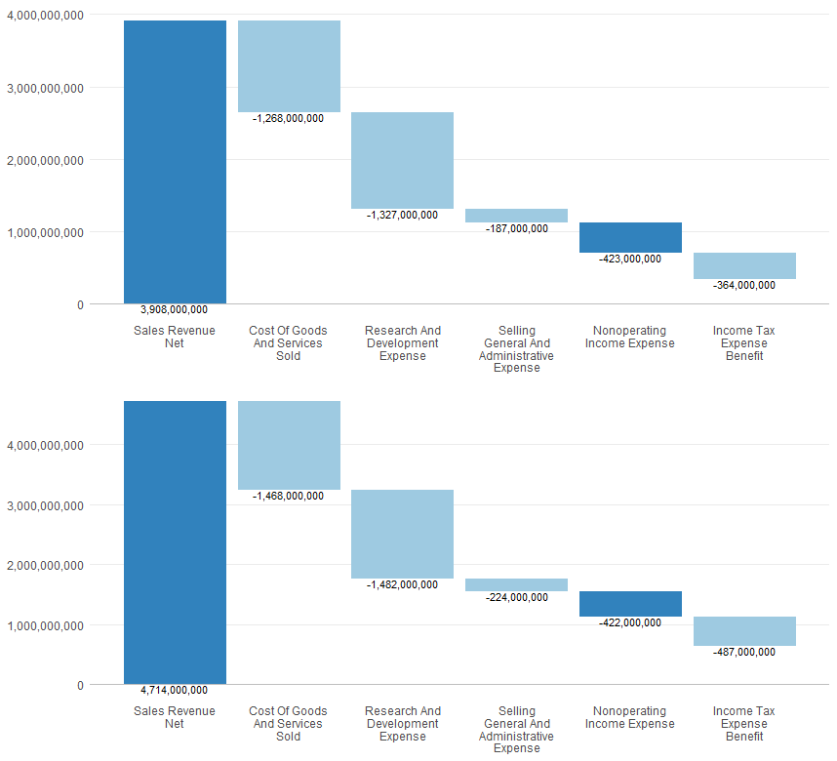

**Figure 2: Revenue and Expenses for Airtel Africa**

**Figures 1 and 2** demonstrate that Airtel Africa is in good financial health, with positive trends in profitability, liquidity, and operational efficiency. The growth in total assets has improved liquidity, while the increase in net income, positive operating income, and gross profit trend reflects a well-managed and thriving business. However, it is worth noting that the decrease in cash and the increase in long-term debt require attention, as they can affect the company's financial flexibility.

Vodafone Group PLC is a multinational telecommunications company in several countries worldwide". The company offers various services, including voice, messaging, data, and fixed-line solutions to consumers and enterprise customers. Vodafone is known for its high-quality network coverage, innovative products, and exceptional customer service *(Yahoo Finance, 2023)*.

Their mobile connectivity services include end-to-end services for mobile voice and data, messaging, device management, BYOx, and telecoms management. Additionally, they provide fixed line connectivity services such as fixed voice and data, broadband, software-defined networks, managed WAN, LAN, Ethernet, and satellite. They also offer financial services and business and merchant services *(Yahoo Finance, 2023)*.

Vodafone provides consumers with Internet of Things (IoT) propositions, security and insurance products, mobile services, logistics, fleet management, and innovative metering services. They offer digital services like mobile application development, multi-access edge computing, worker insights, AI assistance, drone detection, visual inspection, mixed reality, and the Vodafone Analytics platform. They also provide traditional IT hosting services such as colocation, managed hosting, security, hosting infrastructure, and flexible computing for the government *(Yahoo Finance, 2023)*.

In addition, Vodafone offers integrated business communication services, fixed mobile convergence services, carrier services, and IoT devices comprising managed tablets and integrated terminals. Further, they offer digital cloud-based television platforms, a multi-cloud platform for Vodafone Business, and productivity solutions. Additionally, they provide M-Pesa, an African mobile money platform for financial services and payments *(Yahoo Finance, 2023)*.

Vodafone serves customers in various industries, including manufacturing, retail, automotive, banking, healthcare, smart cities, agriculture, transport, and energy management. They offer their products and services through both digital and physical channels. The company is headquartered in Newbury, United Kingdom, and was founded in 1984 *(Yahoo Finance, 2023)*.

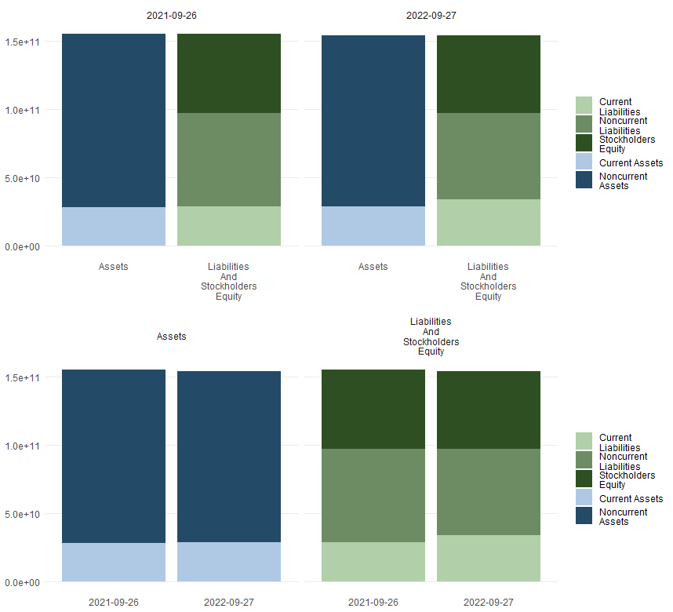

**Figure 3: Assets and Liabilities for Vodafone Group**

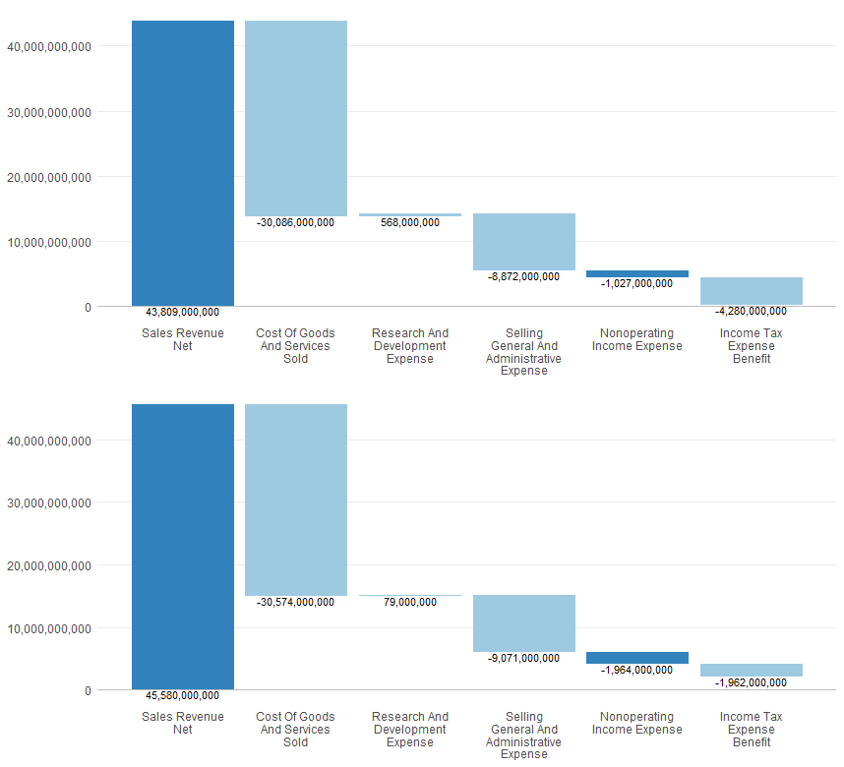

**Figure 4: Revenues and Expenses for Vodafone Group**

**Figures 3 and 4** depicted above indicate that an analysis of Vodafone Group's financial statements shows a positive financial health and performance. The rise in net income, operating income, and gross profit suggests that the company's profitability and operational efficiency have improved. Although total assets and stockholders' equity have slightly declined, the company's ability to manage liabilities and generate higher profits indicates a robust financial position.

## **AIM OF THE REPORT**

This report is a group assignment that aims to comprehensively analyse the financial statements and market data of two prominent companies in the telecommunication sector, namely Airtel Africa and Vodafone Group. The analysis involves comparing the reporting years 2021 and 2022.

The report's structure is as follows: it begins with the company profiles section, which provides detailed information about the two companies' services, subsidiaries, and financial health. Both companies' financial health and performance are analysed using various financial ratios and horizontal and vertical analyses of critical metrics. The primary source of information for the analysis is **Yahoo Finance**.

R-studio software will be used to carry out various analyses. The study covers horizontal and vertical analysis and ratio analysis, which includes liquidity, profitability, efficiency, solvency, financial gearing and operational aspects. The subsequent section focuses on market data analysis, which introduces the Capital Asset Pricing Model (CAPM) and its relevance in understanding the relationship between systematic and expected return assets, particularly stocks. The report emphasizes the importance of CAPM in determining market equilibrium under risk conditions. To summarise, the report provides a comprehensive analysis of the telecommunication sector, covering detailed company profiles, financial health assessments, an in-depth analysis of financial statements and ratios for Airtel Africa and Vodafone Group, and market data analysis that introduces the CAPM model, offering a broader understanding of the companies' positioning in the market.

|  |  |  |  |  |  |
| --- | --- | --- | --- | --- | --- |
| Airtel Africa (AAF.L)  (Currency in USD and all numbers in thousands)  Income Statement from Yahoo Finance | | | | | |
| Breakdown | **TTM** | **3/30/2023** | **3/30/2022** | **3/30/2021** | **3/30/2020** |
| Total Revenue | 5,313,000 | 5,255,000 | 4,714,000 | 3,908,000 | 3,422,000 |
| Operating Revenue | 5,313,000 | 5,255,000 | 4,714,000 | 3,908,000 | 3,422,000 |
| Cost of Revenue | 1,954,000 | 1,678,000 | 1,468,000 | 1,268,000 | 1,193,000 |
| Gross Profit | 3,359,000 | 3,577,000 | 3,246,000 | 2,640,000 | 2,229,000 |
| Operating Expense | 1,577,000 | 1,806,000 | 1,706,000 | 1,514,000 | 1,330,000 |
| Selling General and Administrative | 252,000 | 243,000 | 224,000 | 187,000 | 148,000 |
| General & Administrative Expense | - | - | - | - | 32,000 |
| Selling & Marketing Expense | 252,000 | 243,000 | 224,000 | 187,000 | 148,000 |
| Other Operating Expenses | 194,000 | 471,000 | 451,000 | 382,000 | 333,000 |
| Operating Income | 1,782,000 | 1,771,000 | 1,540,000 | 1,126,000 | 899,000 |
| Net Non Operating Interest Income Expense | -430,000 | -723,000 | -422,000 | -423,000 | -373,000 |
| Interest Income Non Operating | 35,000 | 29,000 | 19,000 | 9,000 | 67,000 |
| Interest Expense Non Operating | 413,000 | 752,000 | 441,000 | 432,000 | 440,000 |
| Total Other Finance Cost | - | 52,000 | 38,000 | 25,000 | 31,000 |
| Pretax Income | 530,000 | 1,034,000 | 1,224,000 | 697,000 | 598,000 |
| Tax Provision | 123,000 | 284,000 | 469,000 | 282,000 | 190,000 |
| Net Income Common Stockholders | 312,000 | 663,000 | 631,000 | 339,000 | 370,000 |
| Net Income | 312,000 | 663,000 | 631,000 | 339,000 | 370,000 |
| Net Income Including Non-Controlling Interests | 407,000 | 750,000 | 755,000 | 415,000 | 408,000 |
| Net Income Continuous Operations | 407,000 | 750,000 | 755,000 | 415,000 | 408,000 |
| Minority Interests | -95,000 | -87,000 | -124,000 | -76,000 | -38,000 |
| Otherunder Preferred Stock Dividend | 0 | 0 | 0 | 0 | 0 |
| Diluted NI Available to Com Stockholders | 312,000 | 663,000 | 631,000 | 339,000 | 370,000 |
| Basic EPS | 0.08 | 0.18 | 0.17 | 0.09 | 0.1 |
| Diluted EPS | 0.08 | 0.18 | 0.17 | 0.09 | 0.1 |
| Basic Average Shares | 3,750,597 | 3,751,666 | 3,754,180 | 3,757,550 | 3,585,635 |
| Diluted Average Shares | 3,752,589 | 3,756,868 | 3,760,109 | 3,759,122 | 3,586,678 |
| Total Operating Income as Reported | 1,770,000 | 1,757,000 | 1,535,000 | 1,119,000 | -901,000 |
| Total Expenses | 3,531,000 | 3,484,000 | 3,174,000 | 2,782,000 | 2,523,000 |
| Net Income from Continuing & Discontinued Operation | 312,000 | 663,000 | 631,000 | 339,000 | 370,000 |
| Normalized Income | 381,881 | 671,568 | 634,085 | 344,670 | 368,635 |
| Interest Income | 35,000 | 29,000 | 19,000 | 9,000 | 67,000 |
| Interest Expense | 413,000 | 752,000 | 441,000 | 432,000 | 440,000 |
| Net Interest Income | -430,000 | -723,000 | -422,000 | -423,000 | -373,000 |
| EBIT | 943,000 | 1,786,000 | 1,665,000 | 1,129,000 | 1,038,000 |
| EBITDA | 1,795,000 | 2,604,000 | 2,409,000 | 1,810,000 | 1,670,000 |
| Reconciled Cost of Revenue | 1,954,000 | 1,678,000 | 1,468,000 | 1,268,000 | 1,193,000 |
| Reconciled Depreciation | 852,000 | 818,000 | 744,000 | 681,000 | 632,000 |
| Net Income from Continuing Operation Net Minority Interest | 312,000 | 663,000 | 631,000 | 339,000 | 370,000 |
| Total Unusual Items Excluding Goodwill | -91,000 | -14,000 | -5,000 | -7,000 | 2,000 |
| Total Unusual Items | -91,000 | -14,000 | -5,000 | -7,000 | 2,000 |
| Normalized EBITDA | 1,886,000 | 2,618,000 | 2,414,000 | 1,817,000 | 1,668,000 |
| Tax Rate for Calcs | 0 | 0 | 0 | 0 | 0 |
| Tax Effect of Unusual Items | -21,119 | -5,432 | -1,915 | -1,330 | 635.4515 |

|  |  |  |  |  |
| --- | --- | --- | --- | --- |
| Airtel Africa (AAF.L)  (Currency in USD and all numbers in thousands)  Balance Sheet from Yahoo Finance | | | | |
| Breakdown | **3/30/2023** | **3/30/2022** | **3/30/2021** | **3/30/2020** |
| Total Assets | 11,166,000 | 10,364,000 | 9,992,000 | 9,325,000 |
| Current Assets | 1,898,000 | 1,997,000 | 1,905,000 | 1,671,000 |
| Cash, Cash Equivalents & Short Term Investments | 845,000 | 982,000 | 1,136,000 | 1,076,000 |
| Cash And Cash Equivalents | 586,000 | 638,000 | 813,000 | 1,010,000 |
| Cash | 313,000 | 357,000 | 523,000 | 174,000 |
| Cash Equivalents | 273,000 | 281,000 | 290,000 | 836,000 |
| Other Short Term Investments | 259,000 | 344,000 | 323,000 | 66,000 |
| Inventory | 15,000 | 3,000 | 7,000 | 3,000 |
| Prepaid Assets | 94,000 | 133,000 | 94,000 | 101,000 |
| Restricted Cash | 630,000 | 671,000 | 465,000 | 301,000 |
| Assets Held for Sale Current | - | 0 | 31,000 | - |
| Hedging Assets Current | 4,000 | 3,000 | 6,000 | 10,000 |
| Other Current Assets | 259,000 | 215,000 | 147,000 | 149,000 |
| Total non-current assets | 9,268,000 | 8,367,000 | 8,087,000 | 7,654,000 |
| Net PPE | 3,941,000 | 3,512,000 | 3,031,000 | 2,730,000 |
| Gross PPE | 5,228,000 | 5,307,000 | 4,728,000 | 4,176,000 |
| Properties | 0 | 0 | 0 | 0 |
| Land And Improvements | 25,000 | 26,000 | 27,000 | 26,000 |
| Buildings And Improvements | 92,000 | 96,000 | 96,000 | 97,000 |
| Machinery Furniture Equipment | 3,402,000 | 3,887,000 | 3,640,000 | 3,155,000 |
| Other Properties | 1,497,000 | 1,109,000 | 799,000 | 639,000 |
| Construction in Progress | 212,000 | 189,000 | 166,000 | 259,000 |
| Accumulated Depreciation | -1,287,000 | -1,795,000 | -1,697,000 | -1,446,000 |
| Goodwill And Other Intangible Assets | 4,728,000 | 4,461,000 | 4,570,000 | 4,429,000 |
| Goodwill | 3,516,000 | 3,827,000 | 3,835,000 | 3,943,000 |
| Other Intangible Assets | 1,212,000 | 634,000 | 735,000 | 486,000 |
| Financial Assets | 9,000 | 3,000 | 6,000 | 0 |
| Non Current Prepaid Assets | 151,000 | 123,000 | 8,000 | 7,000 |
| Other Non Current Assets | 214,000 | 134,000 | 112,000 | 112,000 |
| Total Liabilities Net Minority Interest | 7,358,000 | 6,715,000 | 6,639,000 | 6,044,000 |
| Current Liabilities | 3,572,000 | 3,073,000 | 3,504,000 | 2,488,000 |
| Current Provisions | 83,000 | 69,000 | 65,000 | 70,000 |
| Current Debt And Capital Lease Obligation | 1,339,000 | 1,109,000 | 1,708,000 | 863,000 |
| Current Debt | 944,000 | 786,000 | 1,468,000 | 664,000 |
| Current Capital Lease Obligation | 395,000 | 323,000 | 240,000 | 199,000 |
| Other Current Liabilities | 193,000 | 176,000 | 151,000 | 115,000 |
| Total Non Current Liabilities Net Minority Interest | 3,786,000 | 3,642,000 | 3,135,000 | 3,556,000 |
| Long Term Provisions | 21,000 | 20,000 | 25,000 | 23,000 |
| Long Term Debt And Capital Lease Obligation | 2,885,000 | 2,823,000 | 2,908,000 | 3,416,000 |
| Long Term Debt | 1,233,000 | 1,486,000 | 1,871,000 | 2,446,000 |
| Long Term Capital Lease Obligation | 1,652,000 | 1,337,000 | 1,037,000 | 970,000 |
| Tradeand Other Payables Non Current | - | 5,000 | 11,000 | 9,000 |
| Derivative Product Liabilities | 612,000 | 579,000 | 6,000 | 4,000 |
| Other Non Current Liabilities | 13,000 | 18,000 | 24,000 | 29,000 |
| Total Equity Gross Minority Interest | 3,808,000 | 3,649,000 | 3,353,000 | 3,281,000 |
| Stockholders' Equity | 3,635,000 | 3,502,000 | 3,405,000 | 3,388,000 |
| Capital Stock | 1,879,000 | 1,879,000 | 1,879,000 | 3,420,000 |
| Common Stock | 1,879,000 | 1,879,000 | 1,879,000 | 3,420,000 |
| Additional Paid in Capital | - | - | - | 0 |
| Retained Earnings | - | 3,436,000 | 2,975,000 | 2,805,000 |
| Other Equity Interest | 1,541,000 | 1,541,000 | 1,541,000 | 1,541,000 |
| Minority Interest | 173,000 | 147,000 | -52,000 | -107,000 |
| Total Capitalization | 4,868,000 | 4,988,000 | 5,276,000 | 5,834,000 |
| Common Stock Equity | 3,635,000 | 3,502,000 | 3,405,000 | 3,388,000 |
| Capital Lease Obligations | 2,047,000 | 1,660,000 | 1,277,000 | 1,169,000 |
| Net Tangible Assets | -1,093,000 | -959,000 | -1,165,000 | -1,041,000 |
| Working Capital | -1,674,000 | -1,076,000 | -1,599,000 | -817,000 |
| Invested Capital | 5,812,000 | 5,774,000 | 6,744,000 | 6,498,000 |
| Tangible Book Value | -1,093,000 | -959,000 | -1,165,000 | -1,041,000 |
| Total Debt | 4,224,000 | 3,932,000 | 4,616,000 | 4,279,000 |
| Net Debt | 1,591,000 | 1,634,000 | 2,526,000 | 2,100,000 |
| Share Issued | 3,758,152 | 3,758,152 | 3,758,152 | 3,758,152 |
| Ordinary Shares Number | 3,750,825 | 3,758,152 | 3,754,452 | 3,758,152 |
| Treasury Shares Number | 7,326 | - | 3,700 | - |

|  |  |  |  |  |  |
| --- | --- | --- | --- | --- | --- |
| Vodafone Group PLC (VOD.L)  (Currency in EUR and all numbers in thousands)  Income Statement from Yahoo Finance | | | | | |
| Breakdown | **TTM** | **3/30/2023** | **3/30/2022** | **3/30/2021** | **3/30/2020** |
| Total Revenue | 45,706,000 | 45,706,000 | 45,580,000 | 43,809,000 | 44,974,000 |
| Operating Revenue | 45,706,000 | 45,706,000 | 45,580,000 | 43,809,000 | 44,974,000 |
| Cost of Revenue | 30,850,000 | 30,850,000 | 30,574,000 | 30,086,000 | 30,682,000 |
| Gross Profit | 14,856,000 | 14,856,000 | 15,006,000 | 13,723,000 | 14,292,000 |
| Operating Expense | 323,000 | 323,000 | 8,992,000 | 8,304,000 | 5,343,000 |
| Selling General and Administrative | 9,421,000 | 9,421,000 | 9,071,000 | 8,872,000 | 9,624,000 |
| General & Administrative Expense | 6,092,000 | 6,092,000 | 5,713,000 | 5,350,000 | 5,810,000 |
| Selling & Marketing Expense | 3,329,000 | 3,329,000 | 3,358,000 | 3,522,000 | 3,814,000 |
| Other Operating Expenses | -9,098,000 | -9,098,000 | -79,000 | -568,000 | -4,281,000 |
| Operating Income | 14,533,000 | 14,533,000 | 6,014,000 | 5,419,000 | 8,949,000 |
| Net Non Operating Interest Income Expense | -2,016,000 | -1,728,000 | -1,964,000 | -1,027,000 | -3,549,000 |
| Interest Income Non Operating | 248,000 | 561,000 | 428,000 | 485,000 | 248,000 |
| Interest Expense Non Operating | 2,577,000 | 1,728,000 | 1,964,000 | 1,027,000 | 3,549,000 |
| Pretax Income | 12,816,000 | 12,816,000 | 3,954,000 | 4,400,000 | 795,000 |
| Tax Provision | 481,000 | 481,000 | 1,330,000 | 3,864,000 | 1,250,000 |
| Net Income Common Stockholders | 11,838,000 | 11,838,000 | 2,088,000 | 112,000 | -920,000 |
| Net Income | 11,838,000 | 11,838,000 | 2,088,000 | 112,000 | -920,000 |
| Net Income Including Non-Controlling Interests | 12,335,000 | 12,335,000 | 2,624,000 | 536,000 | -455,000 |
| Net Income Continuous Operations | 12,335,000 | 12,335,000 | 2,624,000 | 536,000 | -455,000 |
| Net Income Discontinuous Operations | 0 | - | - | 0 | 0 |
| Minority Interests | -497,000 | -497,000 | -536,000 | -424,000 | -465,000 |
| Otherunder Preferred Stock Dividend | 0 | 0 | 0 | 0 | 0 |
| Diluted NI Available to Com Stockholders | 11,838,000 | 11,838,000 | 2,088,000 | 112,000 | -920,000 |
| Basic EPS | 0.43 | 0.43 | 0.08 | 0 | -0.03 |
| Diluted EPS | 0.43 | 0.43 | 0.08 | 0 | -0.03 |
| Basic Average Shares | 27,680,000 | 27,680,000 | 29,012,000 | 29,592,000 | 29,422,000 |
| Diluted Average Shares | 27,775,000 | 27,775,000 | 29,109,000 | 29,592,000 | 29,422,000 |
| Total Operating Income as Reported | 14,296,000 | 14,296,000 | 5,664,000 | 5,097,000 | 4,099,000 |
| Rent Expense Supplemental | 0 | - | - | 0 | 0 |
| Total Expenses | 31,173,000 | 31,173,000 | 39,566,000 | 38,390,000 | 36,025,000 |
| Net Income from Continuing & Discontinued Operation | 11,838,000 | 11,838,000 | 2,088,000 | 112,000 | -920,000 |
| Normalized Income | 12,040,982 | 12,482,540 | 2,460,504 | 649,840 | 2,516,715 |
| Interest Income | 248,000 | 561,000 | 428,000 | 485,000 | 248,000 |
| Interest Expense | 2,577,000 | 1,728,000 | 1,964,000 | 1,027,000 | 3,549,000 |
| Net Interest Income | -2,016,000 | -1,728,000 | -1,964,000 | -1,027,000 | -3,549,000 |
| EBIT | 15,393,000 | 14,544,000 | 5,918,000 | 5,427,000 | 4,344,000 |
| EBITDA | 29,011,000 | 14,544,000 | 5,918,000 | 5,427,000 | 18,518,000 |
| Reconciled Cost of Revenue | 30,850,000 | 30,850,000 | 30,574,000 | 30,086,000 | 30,682,000 |
| Reconciled Depreciation | 13,618,000 | 13,618,000 | 13,845,000 | 14,101,000 | 14,174,000 |
| Net Income from Continuing Operation Net Minority Interest | 11,838,000 | 11,838,000 | 2,088,000 | 112,000 | -920,000 |
| Total Unusual Items Excluding Goodwill | -211,000 | -670,000 | -561,000 | -664,000 | -2,345,000 |
| Total Unusual Items | -211,000 | -670,000 | -561,000 | -664,000 | -660,000 |
| Normalized EBITDA | 29,222,000 | 15,214,000 | 6,479,000 | 6,091,000 | 19,178,000 |
| Tax Rate for Calcs | 0 | 0 | 0 | 0 | 0 |
| Tax Effect of Unusual Items | -8,018 | -25,460 | -188,496 | -126,160 | -593,285 |

|  |  |  |  |  |
| --- | --- | --- | --- | --- |
| Vodafone Group PLC (VOD.L)  (Currency in EUR and all numbers in thousands)  Balance Sheet from Yahoo Finance | | | | |
| Breakdown | **3/30/2023** | **3/30/2022** | **3/30/2021** | **3/30/2020** |
| Total Assets | 155,521,000 | 153,953,000 | 155,063,000 | 168,168,000 |
| Current Assets | 30,662,000 | 28,537,000 | 28,270,000 | 34,251,000 |
| Cash, Cash Equivalents & Short Term Investments | 18,722,000 | 15,427,000 | 14,980,000 | 20,373,000 |
| Cash And Cash Equivalents | 11,705,000 | 7,496,000 | 5,821,000 | 13,284,000 |
| Cash | 3,924,000 | 2,220,000 | 2,705,000 | 1,947,000 |
| Cash Equivalents | 7,781,000 | 5,276,000 | 3,116,000 | 2,202,000 |
| Other Short Term Investments | 7,017,000 | 7,931,000 | 9,159,000 | 7,089,000 |
| Inventory | 956,000 | 836,000 | 676,000 | 585,000 |
| Prepaid Assets | 835,000 | 872,000 | 1,082,000 | 859,000 |
| Restricted Cash | 239,000 | 698,000 | 4,848,000 | 1,460,000 |
| Current Deferred Assets | 1,471,000 | 1,403,000 | 1,364,000 | 1,293,000 |
| Assets Held for Sale Current | - | 959,000 | 1,257,000 | 1,607,000 |
| Hedging Assets Current | 482,000 | 410,000 | 239,000 | 752,000 |
| Total non-current assets | 124,859,000 | 125,416,000 | 126,793,000 | 133,917,000 |
| Net PPE | 37,992,000 | 40,804,000 | 41,243,000 | 39,197,000 |
| Gross PPE | 88,555,000 | 93,682,000 | 90,862,000 | 87,631,000 |
| Properties | 1,997,000 | 2,346,000 | 2,315,000 | 2,201,000 |
| Machinery Furniture Equipment | 74,460,000 | 79,320,000 | 75,974,000 | 70,022,000 |
| Other Properties | 12,098,000 | 12,016,000 | 12,573,000 | 15,408,000 |
| Accumulated Depreciation | -50,563,000 | -52,878,000 | -49,619,000 | -48,434,000 |
| Goodwill And Other Intangible Assets | 47,207,000 | 53,244,000 | 53,549,000 | 53,523,000 |
| Goodwill | 27,615,000 | 31,884,000 | 31,731,000 | 31,271,000 |
| Other Intangible Assets | 19,592,000 | 21,360,000 | 21,818,000 | 22,252,000 |
| Financial Assets | 5,642,000 | 4,216,000 | 2,912,000 | 8,424,000 |
| Non Current Deferred Assets | 690,000 | 630,000 | 580,000 | 583,000 |
| Non Current Deferred Taxes Assets | 19,316,000 | 19,089,000 | 21,569,000 | 23,606,000 |
| Non Current Prepaid Assets | 296,000 | 231,000 | 247,000 | 212,000 |
| Defined Pension Benefit | 329,000 | 555,000 | 60,000 | 590,000 |
| Total Liabilities Net Minority Interest | 91,038,000 | 96,976,000 | 97,247,000 | 105,543,000 |
| Current Liabilities | 34,584,000 | 33,647,000 | 28,711,000 | 33,507,000 |
| Current Provisions | 674,000 | 667,000 | 892,000 | 1,024,000 |
| Current Debt And Capital Lease Obligation | 14,721,000 | 11,961,000 | 8,488,000 | 11,826,000 |
| Current Debt | 6,789,000 | 6,318,000 | 4,403,000 | 11,826,000 |
| Current Capital Lease Obligation | 3,046,000 | 2,729,000 | 3,123,000 | 2,986,000 |
| Total Non Current Liabilities Net Minority Interest | 56,454,000 | 63,329,000 | 68,536,000 | 72,036,000 |
| Long Term Provisions | 1,572,000 | 1,881,000 | 1,747,000 | 1,474,000 |
| Long Term Debt And Capital Lease Obligation | 51,669,000 | 58,131,000 | 59,272,000 | 62,892,000 |
| Long Term Debt | 41,351,000 | 48,321,000 | 49,363,000 | 62,892,000 |
| Long Term Capital Lease Obligation | 10,318,000 | 9,810,000 | 9,909,000 | 9,077,000 |
| Trade and Other Payables Non Current | 2,184,000 | 2,516,000 | 4,909,000 | 5,189,000 |
| Non Current Accrued Expenses | 48,000 | 28,000 | 47,000 | 60,000 |
| Derivative Product Liabilities | 1,116,000 | 1,506,000 | 3,919,000 | 4,177,000 |
| Total Equity Gross Minority Interest | 64,483,000 | 56,977,000 | 57,816,000 | 62,625,000 |
| Stockholders' Equity | 63,399,000 | 54,687,000 | 55,804,000 | 61,410,000 |
| Capital Stock | 4,797,000 | 4,797,000 | 4,797,000 | 4,797,000 |
| Common Stock | 4,797,000 | 4,797,000 | 4,797,000 | 4,797,000 |
| Additional Paid in Capital | 149,145,000 | 149,018,000 | 150,812,000 | 152,629,000 |
| Retained Earnings | -113,086,000 | -122,118,000 | -121,587,000 | -120,349,000 |
| Treasury Stock | 7,719,000 | 7,278,000 | 6,172,000 | 7,802,000 |
| Minority Interest | 1,084,000 | 2,290,000 | 2,012,000 | 1,215,000 |
| Total Capitalization | 63,399,000 | 54,687,000 | 55,804,000 | 61,410,000 |
| Common Stock Equity | 63,399,000 | 54,687,000 | 55,804,000 | 61,410,000 |
| Capital Lease Obligations | 13,364,000 | 12,539,000 | 13,032,000 | 12,063,000 |
| Net Tangible Assets | 16,192,000 | 1,443,000 | 2,255,000 | 7,887,000 |
| Working Capital | -3,922,000 | -5,110,000 | -441,000 | 744,000 |
| Invested Capital | 63,399,000 | 54,687,000 | 55,804,000 | 61,410,000 |
| Tangible Book Value | 16,192,000 | 1,443,000 | 2,255,000 | 7,887,000 |
| Total Debt | 66,390,000 | 70,092,000 | 67,760,000 | 74,718,000 |
| Net Debt | 36,435,000 | 47,143,000 | 49,686,000 | 61,434,000 |
| Share Issued | 28,818,256 | 28,817,628 | 28,816,836 | 28,815,915 |
| Ordinary Shares Number | 26,992,565 | 28,370,051 | 28,224,193 | 26,772,165 |
| Treasury Shares Number | 1,825,691 | 447,577 | 592,642 | 2,043,750 |

# **ANALYSIS OF FINANCIAL STATEMENTS**

## **Horizontal and Vertical Analysis**

Horizontal or trend analysis involves comparing financial information over multiple reporting periods, while vertical analysis entails listing line items as a percentage of another item on a financial statement *(Bragg, 2023)*. Vertical analysis helps stakeholders assess the relative proportion of different financial statement items within a single period, making it easier to identify trends, patterns, and areas of concern. However, horizontal analysis helps stakeholders understand how a company’s financial performance evolves over several periods. It reveals whether specific line items are increasing or decreasing and by what percentage *(Frm, 2023)*. Investors and analysts can use horizontal analysis to understand a company's financial performance for several years. It helps them identify trends and growth patterns and evaluate the changes in different items over time. This information can then be used to make projections about the company's future performance *(Tuovila, 2023)*. Vertical analysis does not compare the two periods directly; instead, it breaks down each period separately to compare the percentage changes and to determine why they may have changed *(FutureLearn, 2022)*.

Analyzing the income statement and balance sheet from 2021 to 2022 for Airtel Africa and Vodafone Group can give a complete picture of operational results and reveal information about the company's financial performance and growth trends.

* **Horizontal Analysis (%)** = x 100
* **Vertical Analysis (Income Statement)** = x 100
* **Vertical Analysis (Balance Sheet)** = x 100

|  |  |  |  |  |  |  |
| --- | --- | --- | --- | --- | --- | --- |
| AIRTEL AFRICA | | | | | | |
| HORIZONTAL AND VERTICAL ANALYSIS | | | | | | |
| item | **27/09/2022** | **26/09/2021** | **Horizontal Variation** | **Variation %** | **Vertical 2022** | **Vertical 2021** |
| Assets = | 10364.00 | 9992.00 | 372.00 | 3.72 | 100.000000000 | 100.000000 |
| + AssetsCurrent = | 1997.00 | 1905.00 | 92.00 | 4.83 | 19.268622154 | 19.065250 |
| + CashAndCashEquivalentsAtCarryingValue | 982.00 | 1136.00 | -154.00 | -13.56 | 9.475106137 | 11.369100 |
| + AvailableForSaleSecuritiesCurrent | 0.00 | 0.00 | 0.00 | NaN | 0.000000000 | 0.000000 |
| + AccountsReceivableNetCurrent | 0.00 | 0.00 | 0.00 | NaN | 0.000000000 | 0.000000 |
| + InventoryNet | 3.00 | 7.00 | -4.00 | -57.14 | 0.028946353 | 0.070056 |
| + DeferredTaxAssetsNetCurrent | 0.00 | 0.00 | 0.00 | NaN | 0.000000000 | 0.000000 |
| + NontradeReceivablesCurrent | 0.00 | 0.00 | 0.00 | NaN | 0.000000000 | 0.000000 |
| + OtherAssetsCurrent | 1012.00 | 762.00 | 250.00 | 32.81 | 9.764569664 | 7.626101 |
| + AvailableForSaleSecuritiesNoncurrent | 0.00 | 0.00 | 0.00 | NaN | 0.000000000 | 0.000000 |
| + PropertyPlantAndEquipmentNet | 3512.00 | 3031.00 | 481.00 | 15.87 | 33.886530297 | 30.334270 |
| + Goodwill | 3827.00 | 3835.00 | -8.00 | -0.21 | 36.925897337 | 38.380700 |
| + IntangibleAssetsNetExcludingGoodwill | 634.00 | 735.00 | -101.00 | -13.74 | 6.117329217 | 7.355885 |
| + OtherAssetsNoncurrent | 394.00 | 486.00 | -92.00 | -18.93 | 3.801620996 | 4.863891 |
| LiabilitiesAndStockholdersEquity = | 10364.00 | 9992.00 | 372.00 | 3.72 | 100.000000000 | 100.000000 |
| + Liabilities = | 6715.00 | 6639.00 | 76.00 | 1.14 | 64.791586260 | 66.443150 |
| + LiabilitiesCurrent = | 3073.00 | 3504.00 | -431.00 | -12.3 | 29.650714010 | 35.068050 |
| + AccountsPayableCurrent | 404.00 | 366.00 | 38.00 | 10.38 | 3.898108838 | 3.662930 |
| + AccruedLiabilitiesCurrent | 2507.00 | 3003.00 | -496.00 | -16.52 | 24.189502123 | 30.054040 |
| + DeferredRevenueCurrent | 162.00 | 135.00 | 27.00 | 20.00 | 1.563103049 | 1.351081 |
| + CommercialPaper | 0.00 | 0.00 | 0.00 | NaN | 0.000000000 | 0.000000 |
| + DeferredRevenueNoncurrent | 0.00 | 0.00 | 0.00 | NaN | 0.000000000 | 0.000000 |
| + LongTermDebt | 1486.00 | 1871.00 | -385.00 | -20.58 | 14.338093400 | 18.724980 |
| + OtherLiabilitiesNoncurrent | 2156.00 | 1264.00 | 892.00 | 70.57 | 20.802778850 | 12.650120 |
| + CommitmentsAndContingencies | 0.00 | 0.00 | 0.00 | NaN | 0.000000000 | 0.000000 |
| + StockholdersEquity = | 3649.00 | 3353.00 | 296.00 | 8.83 | 35.208413740 | 33.556850 |
| + CommonStockValue | 1879.00 | 1879.00 | 0.00 | 0.00 | 18.130065612 | 18.805040 |
| + RetainedEarningsAccumulatedDeficit | 3436.00 | 2975.00 | 461.00 | 15.50 | 33.153222694 | 29.773820 |
| + AccumulatedOtherComprehensiveIncomeLossNetOfTax | -1666.15 | -1500.95 | -165.20 | 11.01 | -16.076292937 | -15.021500 |
| + CommonStocksIncludingAdditionalPaidInCapital | 0.15 | -0.05 | 0.20 | -382.69 | 0.001418371 | -0.000520 |

|  |  |  |  |  |  |  |
| --- | --- | --- | --- | --- | --- | --- |
| Item | 27/09/2022 | 26/09/2021 | Horizontal Variation | Variation % | Vertical 2022 | Vertical 2021 |
| NetIncomeLoss = | 631 | 339 | 292 | 86.14 | 13.385660 | 8.674514 |
| + IncomeLossFromContinuingOperationsBefore... = | 1118 | 703 | 415 | 59.03 | 23.716589 | 17.988741 |
| + OperatingIncomeLoss = | 1540 | 1126 | 414 | 36.77 | 32.668647 | 28.812692 |
| + GrossProfit = | 3246 | 2640 | 606 | 22.95 | 68.858719 | 67.553736 |
| + SalesRevenueNet | 4714 | 3908 | 806 | 20.62 | 100.000000 | 100.000000 |
| - CostOfGoodsAndServicesSold | 1468 | 1268 | 200 | 15.77 | 31.141281 | 32.446264 |
| - OperatingExpenses = | 1706 | 1514 | 192 | 12.68 | 36.190072 | 38.741044 |
| + ResearchAndDevelopmentExpense | 1482 | 1327 | 155 | 11.68 | 31.438269 | 33.955988 |
| + SellingGeneralAndAdministrativeExpense | 224 | 187 | 37 | 19.79 | 4.751803 | 4.785056 |
| + NonoperatingIncomeExpense | -422 | -423 | 1 | -0.24 | -8.952058 | -10.823951 |
| - IncomeTaxExpenseBenefit | 487 | 364 | 123 | 33.79 | 10.220929 | 9.314227 |

|  |  |  |  |  |  |  |
| --- | --- | --- | --- | --- | --- | --- |
| VODAFONE GROUP | | | | | | |
| HORIZONTAL AND VERTICAL ANALYSIS | | | | | | |
| item | **27/09/2022** | **26/09/2021** | **Horizontal Variation** | **Variation %** | **Vertical 2022** | **Vertical 2021** |
| Assets = | 153953 | 155063 | -1110 | -0.72 | 100.000000 | 100.000000 |
| + AssetsCurrent = | 28537 | 28270 | 267 | 0.94 | 18.536177 | 18.231300 |
| + CashAndCashEquivalentsAtCarryingValue | 15427 | 14980 | 447 | 2.98 | 10.020591 | 9.660590 |
| + AvailableForSaleSecuritiesCurrent | 0 | 0 | 0 | NaN | 0.000000 | 0.000000 |
| + AccountsReceivableNetCurrent | 0 | 0 | 0 | NaN | 0.000000 | 0.000000 |
| + InventoryNet | 836 | 676 | 160 | 23.67 | 0.543023 | 0.435952 |
| + DeferredTaxAssetsNetCurrent | 0 | 0 | 0 | NaN | 0.000000 | 0.000000 |
| + NontradeReceivablesCurrent | 0 | 0 | 0 | NaN | 0.000000 | 0.000000 |
| + OtherAssetsCurrent | 12274 | 12614 | -340 | -2.70 | 7.972563 | 8.134758 |
| + AvailableForSaleSecuritiesNoncurrent | 0 | 0 | 0 | NaN | 0.000000 | 0.000000 |
| + PropertyPlantAndEquipmentNet | 40804 | 41243 | -439 | -1.06 | 26.504193 | 26.597577 |
| + Goodwill | 31884 | 31731 | 153 | 0.48 | 20.710217 | 20.463296 |
| + IntangibleAssetsNetExcludingGoodwill | 21360 | 21818 | -458 | -2.10 | 13.874364 | 14.070410 |
| + OtherAssetsNoncurrent | 31368 | 32001 | -633 | -1.98 | 20.375050 | 20.637418 |
| LiabilitiesAndStockholdersEquity = | 153953 | 155063 | -1110 | -0.72 | 100.000000 | 100.000000 |
| + Liabilities = | 96976 | 97247 | -271 | -0.28 | 62.990653 | 62.714510 |
| + LiabilitiesCurrent = | 33647 | 28711 | 4936 | 17.19 | 21.855371 | 18.515700 |
| + AccountsPayableCurrent | 19661 | 18070 | 1591 | 8.80 | 12.770781 | 11.653328 |
| + AccruedLiabilitiesCurrent | 11961 | 8488 | 3473 | 40.92 | 7.769254 | 5.473904 |
| + DeferredRevenueCurrent | 2025 | 2153 | -128 | -5.95 | 1.315337 | 1.388468 |
| + CommercialPaper | 0 | 0 | 0 | NaN | 0.000000 | 0.000000 |
| + DeferredRevenueNoncurrent | 2516 | 4909 | -2393 | -48.75 | 1.634265 | 3.165810 |
| + LongTermDebt | 58131 | 59272 | -1141 | -1.93 | 37.758926 | 38.224464 |
| + OtherLiabilitiesNoncurrent | 2682 | 4355 | -1673 | -38.42 | 1.742090 | 2.808536 |
| + CommitmentsAndContingencies | 0 | 0 | 0 | NaN | 0.000000 | 0.000000 |
| + StockholdersEquity = | 56977 | 57816 | -839 | -1.45 | 37.009347 | 37.285490 |
| + CommonStockValue | 4797 | 4797 | 0 | 0.00 | 3.115886 | 3.093581 |
| + RetainedEarningsAccumulatedDeficit | -122118 | -121587 | -531 | 0.44 | -79.321611 | -78.411355 |
| + AccumulatedOtherComprehensiveIncomeLossNetOfTax | 25280 | 23794 | 1486 | 6.25 | 16.420596 | 15.344731 |
| + CommonStocksIncludingAdditionalPaidInCapital | 149018 | 150812 | -1794 | -1.19 | 96.794476 | 97.258534 |

|  |  |  |  |  |  |  |
| --- | --- | --- | --- | --- | --- | --- |
| item | 27/09/2022 | 26/09/2021 | Horizontal Variation | Variation % | Vertical 2022 | Vertical 2021 |
| NetIncomeLoss = | 2088 | 112 | 1976 | 1764.29 | 4.5809566 | 0.2556552 |
| + IncomeLossFromContinuingOperationsBefore... = | 4050 | 4392 | -342 | -7.79 | 8.8854761 | 10.0253373 |
| + OperatingIncomeLoss = | 6014 | 5419 | 595 | 10.98 | 13.1943835 | 12.3696044 |
| + GrossProfit = | 15006 | 13723 | 1283 | 9.35 | 32.9223344 | 31.3246137 |
| + SalesRevenueNet | 45580 | 43809 | 1771 | 4.04 | 100.0000000 | 100.0000000 |
| - CostOfGoodsAndServicesSold | 30574 | 30086 | 488 | 1.62 | 67.0776656 | 68.6753863 |
| - OperatingExpenses = | 8992 | 8304 | 688 | 8.29 | 19.7279509 | 18.9550092 |
| + ResearchAndDevelopmentExpense | -79 | -568 | 489 | -86.09 | -0.1733216 | -1.2965372 |
| + SellingGeneralAndAdministrativeExpense | 9071 | 8872 | 199 | 2.24 | 19.9012725 | 20.2515465 |
| + NonoperatingIncomeExpense | -1964 | -1027 | -937 | 91.24 | -4.3089074 | -2.3442672 |
| - IncomeTaxExpenseBenefit | 1962 | 4280 | -2318 | -54.16 | 4.3045195 | 9.769682 |

## **Ratio Analysis**

To effectively compare Airtel Africa and Vodafone Group, it is necessary to perform a financial ratio analysis*. Takeuchi* states, "It is the technique of comparing the relationship (or ratio) between two or more items of financial data from a company's financial statements" *(Takeuchi, 2021)*.

### LIQUIDITY

Liquidity analysis evaluates a company’s ability to meet its immediate debt obligations from its current assets.

* **Current ratio** =

|  |  |  |  |
| --- | --- | --- | --- |
| **Airtel Africa** | | **Vodafone Group** | |
| **2022** | **2021** | **2022** | **2021** |
| ≈ 0.65 | ≈ 0.54 | ≈ 0.85 | ≈ 0.98 |
| 0.65:1 | 0.54:1 | 0.85:1 | 0.98:1 |

Airtel Africa's current ratio has improved in 2022 compared to 2021. A current ratio above 1 is considered a good sign for a company's short-term financial health, indicating that it has more current assets than current liabilities. On the other hand, Vodafone Group's current ratio has decreased from 2021 to 2022, which may suggest that the company's ability to cover its short-term liabilities with its current assets has decreased in 2022 compared to 2021. Even though a ratio above 1 is still desirable in this case, the decrease in the ratio can indicate lower short-term financial stability.

* **Quick ratio** = =

|  |  |  |  |
| --- | --- | --- | --- |
| **Airtel Africa** | | **Vodafone Group** | |
| **2022** | **2021** | **2022** | **2021** |
|  |  |  |  |
| 0.65:1 | 0.54:1 | 0.82:1 | 0.96:1 |

It can be observed that the quick ratio of Airtel Africa has improved from 2021 to 2022. This indicates that the company now has a better ability to cover its short-term liabilities with liquid assets. On the other hand, the quick ratio of Vodafone Group has decreased from 2021 to 2022, which suggests that the company's ability to cover its short-term obligations has reduced.

### PROFITABILITY

* **Return on Assets (ROA)** =

|  |  |  |  |
| --- | --- | --- | --- |
| **Airtel Africa** | | **Vodafone Group** | |
| **2022** | **2021** | **2022** | **2021** |
|  |  |  |  |
| 6.2 % | 3.3 % | 1.4 % | 0.07 % |

The ROA has improved for both Airtel Africa and Vodafone Group from 2021 to 2022, indicating that they generate more profit relative to their total assets.

* **Gross Profit Margin** = x 100

|  |  |  |  |
| --- | --- | --- | --- |
| **Airtel Africa** | | **Vodafone Group** | |
| **2022** | **2021** | **2022** | **2021** |
|  |  |  |  |
| 69% | 68% | 33% | 31% |

Airtel Africa had a higher Gross Profit Margin than Vodafone Group in both 2021 and 2022. This suggests that Airtel Africa is more effective in managing its production costs relative to its revenue compared to Vodafone Group.

* **Net Profit Margin** =

|  |  |  |  |
| --- | --- | --- | --- |
| **Airtel Africa** | | **Vodafone Group** | |
| **2022** | **2021** | **2022** | **2021** |
|  |  |  |  |
| 13.38% | 8.68% | 4.58% | 0.26% |

Both companies experienced an increase in Net Profit Margin from 2021 to 2022, showing improved efficiency in managing costs and generating profits relative to their revenue.

* **Return on Equity (ROE)** =

|  |  |  |  |
| --- | --- | --- | --- |
| **Airtel Africa** | | **Vodafone Group** | |
| **2022** | **2021** | **2022** | **2021** |
|  |  |  |  |
| 18 % | 9.7 % | 3.6 % | 0.2 % |

Both companies have shown an increase in ROE from 2021 to 2022, indicating improved profitability in relation to shareholders’ equity over the period.

* **Operating Profit Margin** =

|  |  |  |  |
| --- | --- | --- | --- |
| **Airtel Africa** | | **Vodafone Group** | |
| **2022** | **2021** | **2022** | **2021** |
|  |  |  |  |
| 33 % | 29 % | 13.2 % | 12.4 % |

Both companies demonstrated an increase in their operating profit margin between 2021 and 2022, which indicates an improvement in their ability to generate profits from their operations relative to their revenues.

### EFFICIENCY

* **Inventory Turnover** =

|  |  |  |  |
| --- | --- | --- | --- |
| **Airtel Africa** | | **Vodafone Group** | |
| **2022** | **2021** | **2022** | **2021** |
|  |  |  |  |
| 293.6 | 253.6 | 40.4 | 39.8 |

Airtel Africa had a higher inventory turnover ratio than Vodafone Group in 2021 and 2022. This suggests that Airtel Africa is managing its inventory more efficiently, selling and replacing it more frequently than Vodafone Group.

* **Fixed Assets Turnover** =

|  |  |  |  |
| --- | --- | --- | --- |
| **Airtel Africa** | | **Vodafone Group** | |
| **2022** | **2021** | **2022** | **2021** |
|  |  |  |  |
| 0.57 | 0.48 | 0.36 | 0.35 |

Both companies have shown an improvement in this ratio, with Airtel Africa experiencing a more significant increase. A higher fixed assets ratio indicates better efficiency in utilizing fixed assets to generate revenue.

* **Total Assets Turnover** =

|  |  |  |  |
| --- | --- | --- | --- |
| **Airtel Africa** | | **Vodafone Group** | |
| **2022** | **2021** | **2022** | **2021** |
|  |  |  |  |
| 0.46 | 0.38 | 0.295 | 0.284 |

Airtel Africa has demonstrated a significant improvement in total asset turnover, indicating better utilization of assets to generate revenue. Meanwhile, Vodafone Group has maintained a relatively stable total asset turnover.

### SOLVENCY

* **Debt to Assets Ratio** =

|  |  |  |  |
| --- | --- | --- | --- |
| **Airtel Africa** | | **Vodafone Group** | |
| **2022** | **2021** | **2022** | **2021** |
|  |  |  |  |
| 0.65 | 0.66 | 0.63 | 0.63 |

There was a slight decrease in the ratio for Airtel Africa between 2021 and 2022, indicating an improvement in financial leverage. The ratio remained stable for Vodafone Group during both years, indicating consistent financial leverage.

* **Debt to Equity Ratio** =

|  |  |  |  |
| --- | --- | --- | --- |
| **Airtel Africa** | | **Vodafone Group** | |
| **2022** | **2021** | **2022** | **2021** |
|  |  |  |  |
| 1.84 | 1.98 | 1.7 | 1.68 |

Airtel Africa has displayed a favorable trend with a decrease in its debt-to-equity ratio from 2021 to 2022. This could be observed as a positive sign as it indicates a lower dependence on debt for financing. On the other hand, Vodafone Group's ratio stayed relatively stable, indicating a steady financial structure, although there was a slight increase.

* **Interest Coverage Ratio** =

|  |  |  |  |
| --- | --- | --- | --- |
| **Airtel Africa** | | **Vodafone Group** | |
| **2022** | **2021** | **2022** | **2021** |
|  |  |  |  |
| 3.77 | 2.61 | 3.01 | 5.28 |

A higher interest coverage ratio is considered favourable as it indicates that a company has more income to cover its interest payments. However, if the interest coverage ratio declines, it raises concerns about the company's ability to meet its interest obligations in the future. In 2022, both Airtel Africa and Vodafone Group have moderate interest coverage ratios. Airtel Africa improved from 2021, while Vodafone Group experienced a decrease.

### FINANCIAL GEARING

* **Gearing Ratio** =

|  |  |  |  |
| --- | --- | --- | --- |
| **Airtel Africa** | | **Vodafone Group** | |
| **2022** | **2021** | **2022** | **2021** |
|  |  |  |  |
| 49.95 % | 48.32 % | 52.64 % | 54.24 % |

The ratio for Airtel Africa slightly decreased from 2021 to 2022, indicating a slight improvement in the contribution of long-term lenders to the long-term capital structure of the business. On the other hand, the ratio decreased for Vodafone Group from 2021 to 2022, indicating a reduction in the contribution of long-term lenders to the long-term capital structure of the business.

**I**NVESTMENT

* **Earnings per Share (EPS)** =

|  |  |  |  |
| --- | --- | --- | --- |
| **Airtel Africa** | | **Vodafone Group** | |
| **2022** | **2021** | **2022** | **2021** |
|  |  |  |  |
| 0.168 | 0.09 | 0.07 | 0.004 |

Both Airtel Africa and Vodafone Group saw an increase in earnings per share from 2021 to 2022. This can be seen as a positive indicator of enhanced profitability on a per-share basis for both companies during this time period.

### OPERATIONAL

* **Operating Ratio** = x 100

|  |  |  |  |
| --- | --- | --- | --- |
| **Airtel Africa** | | **Vodafone Group** | |
| **2022** | **2021** | **2022** | **2021** |
|  |  |  |  |
| 36% | 39% | 19.7% | 19% |

There was a decrease in operating ratio for Airtel Africa from 2021 to 2022, indicating improved operational efficiency. However, there was an increase in operating ratio for Vodafone Group from 2021 to 2022, indicating a slight decrease in operational efficiency.

|  |  |  |  |  |
| --- | --- | --- | --- | --- |
| RATIO  ANALYSIS | Airtel Africa | | Vodafone Group | |
| **2022** | **2021** | **2022** | **2021** |
| LIQUIDITY | | | | |
| Current Ratio | 0.65 | 0.54 | 0.85 | 0.98 |
| Quick Ratio | 0.65 | 0.54 | 0.82 | 0.96 |
| PROFITABILITY | | | | |
| Return on Assets (ROA) | 6.2 % | 3.3 % | 1.4 % | 0.07 % |
| Gross Profit Margin | 69 % | 68 % | 33 % | 31 % |
| Net Profit Margin | 13.38 % | 8.68 % | 4.58 % | 0.26 % |
| Return on Equity (ROE) | 18 % | 9.7 % | 3.6 % | 0.2 % |
| Operating Profit Margin | 33 % | 29 % | 13.2 % | 12.4 % |
| EFFICIENCY | | | | |
| Inventory Turnover | 293.6 | 253.6 | 40.4 | 39.8 |
| Fixed Assets Turnover | 0.57 | 0.48 | 0.36 | 0.35 |
| Total Assets Turnover | 0.46 | 0.38 | 0.295 | 0.294 |
| INVESTMENT | | | | |
| Earnings per Share (EPS) | 0.168 | 0.09 | 0.07 | 0.004 |
| FINANCIAL GEARING | | | | |
| Gearing Ratio | 49.95 % | 48.32 % | 52.64 % | 52.24 % |
| SOLVENCY | | | | |
| Debt to Assets Ratio | 0.65 | 0.66 | 0.63 | 0.63 |
| Debt to Equity Ratio | 1.84 | 1.98 | 1.7 | 1.68 |
| Interest Coverage Ratio | 3.77 | 2.61 | 3.01 | 5.28 |
| OPERATIONAL | | | | |
| Operating Ratio | 36 % | 39 % | 19.7 % | 19 % |

# **ANALYSIS OF MARKET DATA**

The Capital Asset Pricing Model (CAPM) was initially developed by Sharpe (1964) and Lintner (1965), which received a Nobel Prize in 1990 *(Bailey, 2023)*. He expanded upon earlier research on risk preferences by Harry Markowitz to develop a novel theory of Capital Asset Prices, a theory of market equilibrium in situations involving risk. "The capital Asset Pricing Model (CAPM) describes the relationship between systematic risk, or the general perils of investing, and expected return for assets, particularly stocks" *(Bailey, 2023)*. The Capital Asset Pricing Model (CAPM) explains the relationship between an asset's expected return, specifically stocks, and its systematic risk or the general risks associated with investing *(Kenton, 2023)*. It is a widely accepted model that connects the anticipated return of an asset, the risk-free rate, and the asset's systematic risk. It presents a structure for calculating the rate of return for an investment considering the time value of money and the risk associated with the asset. The CAPM formula is as follows:

E(Ri) = Rf + *βi* [E(Rm) − Rf]

Where:

* E(Ri) = expected return
* Rf = risk-free rate of interest.
* *βi*= beta (volatility – this estimates risk)
* E(Rm) = expected return on the market portfolio.
* E(Rm) - Rf = Market risk premium or the price per unit risk.

The Capital Asset Pricing Model (CAPM) is a valuation model that helps estimate the expected return on an investment. It does so by adding the risk-free rate to the product of the investment's beta or risk and the expected return of the market and subtracting the risk-free rate from the result. The difference between the two rates is known as the market risk premium.

However, it is important to note that the model has some limitations. Its assumptions are often idealistic, and beta coefficients can be unpredictable and change over time. It is also important to remember that beta only reflects systemic risk, not total risk. Despite these shortcomings, the CAPM remains popular for valuing securities *(Tamplin, 2023)*.

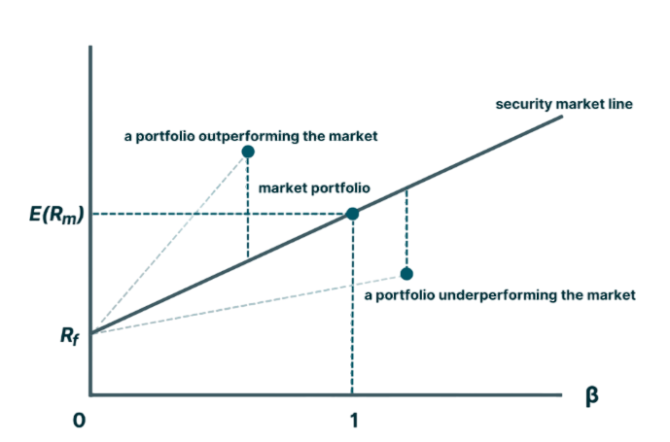

**Figure 5: Capital Asset Pricing Model (CAPM)**

The Security Market Line (SML) is a graphical representation of the Capital Asset Pricing Model (CAPM). It helps determine whether an investment product will provide a favourable expected return compared to its level of risk. Kenton states, "The Security Market Line (SML) is a useful tool for determining whether a security offers a favourable expected return based on its level of risk. When security is plotted on the SML chart, it is considered undervalued if it appears above the line because it offers a greater return against its inherent risk". On the other hand, if the security plots below the SML, it is considered overvalued because the expected return does not outweigh the inherent risk. *(Kenton, 2022)*. As per the Capital Asset Pricing Model (CAPM), if the level of risk increases, the expected return should also increase proportionately. If a security shows a higher return in comparison to the additional risk incurred, it is considered a buying opportunity. However, like all valuation models, CAPM has its limitations due to its idealistic assumptions.

For instance, Beta coefficients are unpredictable and change over time, and they only reflect systemic risk rather than total risk. Despite these limitations, CAPM remains a popular model for valuing securities *(Tamplin, 2023)*. The CAPM formula evaluates whether a stock is fairly valued by comparing its risk and the time value of money with its expected return.

|  |  |  |  |  |
| --- | --- | --- | --- | --- |
| **Ticker** | **Stock** | **Estimated Returns** | **Betas** | **Weights** |
| AAF.L | Airtel Africa PLC | 0.14 | 0.83 | 0.028 |
| CPG.L | Compass Group PLC | 0.00 | 1.08 | 0.017 |
| AZN.L | AstraZeneca PLC | 0.04 | 0.54 | 0.106 |
| BP.L | BP PLC | 0.02 | 1.20 | 0.091 |
| CRH.L | CRH PLC | 0.07 | 1.15 | 0.040 |
| HSBA.L | HSBC Holdings PLC | 0.02 | 1.03 | 0.006 |
| ULVR.L | Unilever PLC | - 0.01 | 0.47 | 0.331 |
| GSK.L | GlaxoSmithKline PLC | 0.00 | 0.63 | 0.138 |
| VOD.L | Vodafone Group PLC | - 0.05 | 0.88 | 0.001 |
| SHEL.L | Royal Dutch Shell PLC (Shell) | 0.08 | 1.12 | 0.001 |
| DGE.L | Diageo PLC | 0.02 | 0.91 | 0.040 |
| RIO.L | Rio Tinto Group | 0.05 | 0.97 | 0.008 |
| PRU.L | Prudential PLC | - 0.03 | 1.42 | 0.002 |
| GLEN.L | Glencore PLC | 0.12 | 1.24 | 0.020 |
| REL.L | RELX PLC | 0.07 | 0.79 | 0.004 |
| LLOY.L | Lloyds Banking Group PLC | 0.03 | 1.23 | 0.002 |
| RR.L | Rolls-Royce Holdings PLC | 0.00 | 1.27 | 0.014 |
| WG.L | Wood Group PLC | - 0.07 | 1.11 | 0.000 |
| NG.L | National Grid PLC | 0.01 | 0.56 | 0.150 |
| ISF.L | iShares PLC | 0.03 | 1.00 |  |

Airtel Africa (AAF.L) is expected to provide a return above the risk-free rate, with a positive expected return of 0.14. It has a beta of 0.83, which means it is less volatile than the market (beta < 1), suggesting a moderate level of risk. On the graph, Airtel Africa's position will be above the security market line.

On the other hand, Vodafone Group (VOD.L) has a negative expected return of -0.05, indicating a potential lower return compared to the risk-free rate. With a beta of 0.88, it is less volatile than the market but more so than Airtel Africa. Vodafone Group's position on the graph will be below the security market line. iShares (ISF.L) represents the market and has a beta of 1.00. Its expected return will be the same as the market return. The graph shows that iShares' position will align with the security market line.

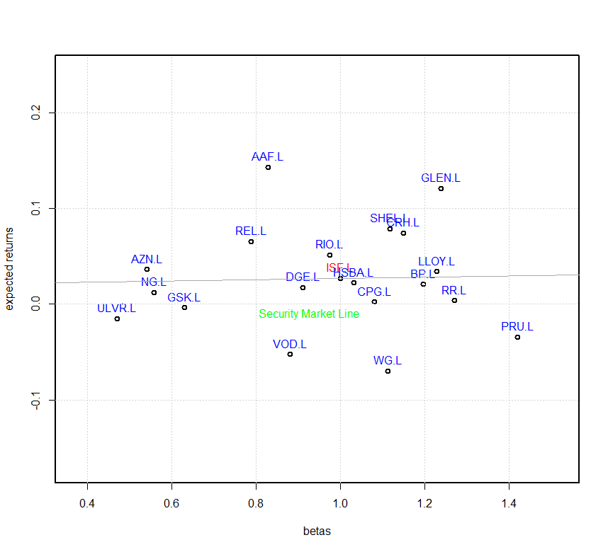

**Figure 6: CAPM FOR SOME UKSTOCKS**

In **Figure 6**, we can see that the security market line has an upward and positive slope trajectory. To determine if Airtel Africa and Vodafone Group shares are overpriced or underpriced, we can use the Capital Asset Pricing Model (CAPM).

The CAPM results show that AAF.L is above the SML and VOD.L is below the market line. This means that AAF.L is undervalued or underpriced, while VOD.L is overvalued or overpriced. AAF.L offers slightly higher returns with a lower beta, which means a lower expected risk. On the other hand, VOD.L has a higher beta than AAF.L, which means it has slightly higher risk. The ISF.L represents the market with an expected return equal to the market return. Both stocks have a beta smaller than one, making them both not very risky for investors. Based on the CAPM analysis, AAF.L represents a better investment opportunity compared to VOD.L as it is underpriced relative to the expected return. However, it's important to consider the level of risk involved, as high beta stocks generally come with risks. Opting to invest in AAF.L could be a better choice since VOD.L has a higher beta value. Additionally, the relationship between beta and expected return was further described as companies with higher beta having less market return, and less beta being related to higher market return. According to the relationship between beta and expected return, AAF.L has a higher potential to provide the expected return as it has a lower beta when compared to VOD.L.

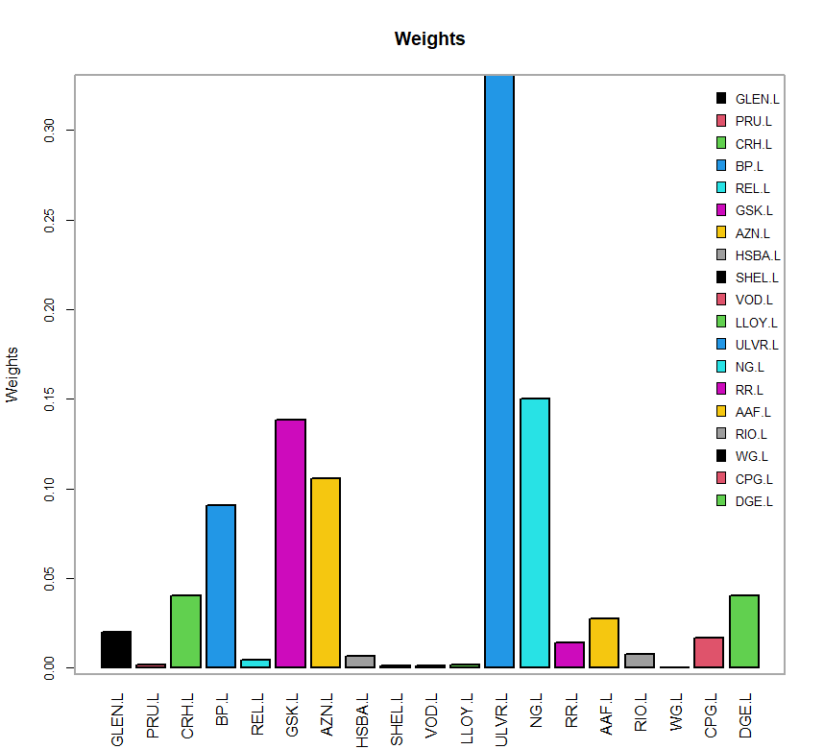

**Figure 7: Portfolio Analytics Graph of UKSTOCKS**

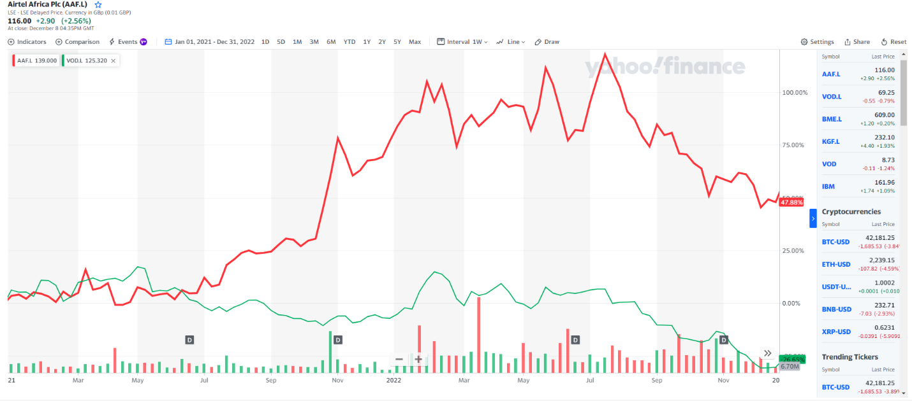

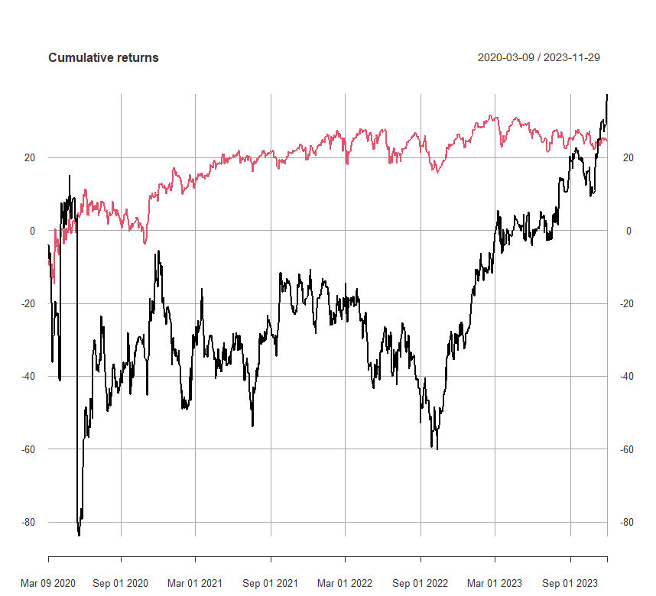

**Figure 8: Cumulative Returns of UKSTOCKS**

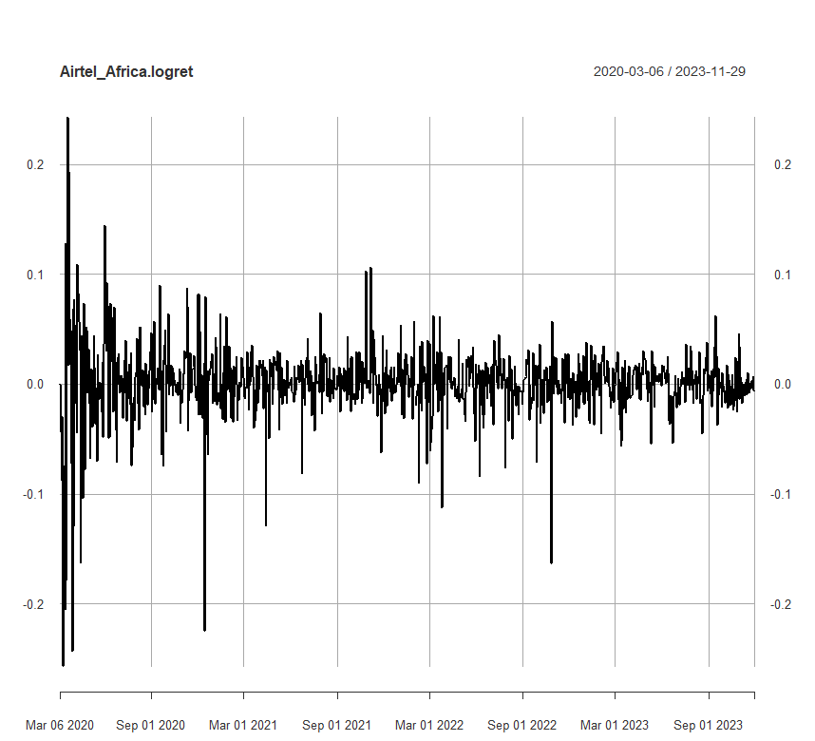

**Figure 9: Log Return for Airtel Africa**

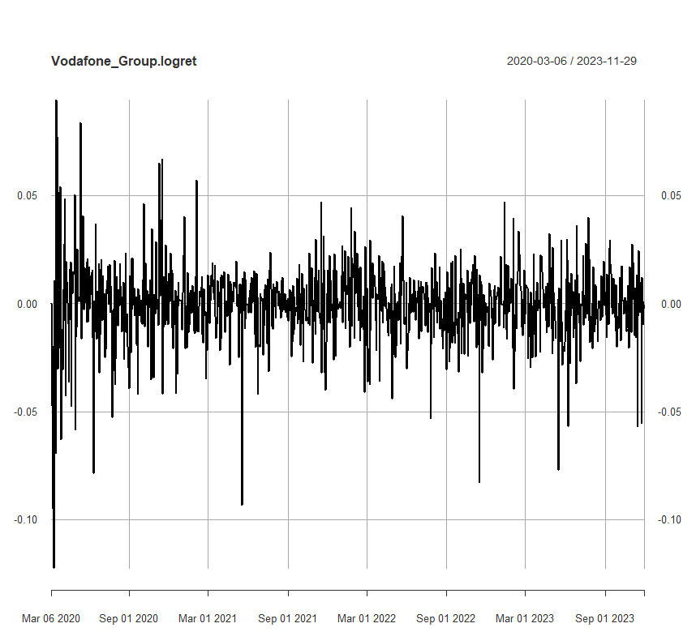

**Figure 10: Log Return for Vodafone Group**

# **Recommendations & Conclusion**

The financial analysis of Airtel Africa (AAF.L) and Vodafone Group (VOD.L) involved a comprehensive analysis of their financial statements, ratio analysis, and an evaluation of market data using the Capital Asset Pricing Model (CAPM). The financial statement analysis revealed various information about the companies' financial performance, growth trends, and overall financial health. Airtel Africa has shown positive growth trends in its financial statements, with increased assets, net income and various margins. The company has efficiently managed its current and non-current assets, leading to improved ratios. However, Vodafone Group also exhibited growth but faced challenges in liquidity and a decrease in the current ratio.

Liquidity analysis indicated that Airtel Africa improved in current and quick ratios from 2021 to 2022, which suggests better short-term financial health. In contrast, Vodafone Group experienced a decrease in both ratios, raising concerns about its ability to cover short-term liabilities with current assets. Profitability ratios, including Return on Assets (ROA), Gross Profit Margin, Net Profit Margin, and Return on Equity (ROE), demonstrated positive trends for both companies from 2021 to 2022. Airtel Africa consistently outperformed Vodafone Group in Gross Profit Margin, indicating better efficiency in managing production costs. Efficiency ratios such as inventory turnover, fixed assets turnover, and total assets turnover showed that Airtel Africa was more efficient than Vodafone Group in managing inventory and generating revenue from fixed and total assets. Solvency ratios, including Debt Assets Ratio, Debt to Equity Ratio, and Interest Coverage Ratio, indicated that both companies maintained relatively stable financial structures. Airtel Africa showed a slight improvement in the Debt-to-Equity Ratio, while Vodafone Group experienced a decrease in the Interest Coverage Ratio. The financial gearing analysis revealed that Airtel Africa and Vodafone Group exhibited positive trends in their Gearing Ratios. Airtel Africa shows a decrease, indicating a slight improvement in long-term financial structure. The additional ratios, including the cost-to-income ratio and Altman Z-Score, provide further insights into the financial health and risk profiles of Airtel Africa and Vodafone Group.

The cost-to-income ratio compares operating expenses to operating income and reflects the efficiency of a company's operations. Airtel Africa showed an improvement in its cost-to-income ratio from 2021 to 2022, indicating increased efficiency. On the other hand, Vodafone Group experienced a slight increase, suggesting a potential concern about operational efficiency. The Altman Z-Score which measures a company's financial distress and bankruptcy risk. A score below 1.8 suggests a high risk of bankruptcy, while a score above 3.0 indicates financial stability. Airtel Africa shows an improvement in its Z score from 2021 to 2022, moving towards a more stable position. In contrast, Vodafone Group's Z score remains in the distressed range, indicating a higher risk of financial distress.

Financial ratio analysis has limitations. Takeuchi states, "It is quantitative rather than qualitative. It, therefore, does not address certain factors that can play a huge role in determining a company's prospects. For example, it cannot analyse the quality of their management. Although financial ratio analysis can be hugely useful, it only tells part of the story" *(Takeuchi, 2021)*.

Moreover, financial ratio is based on certain assumptions and their idealistic nature may not capture all aspects of a company’s prospect. The market data analysis used the Capital Asset Pricing Model (CAPM) to assess the expected returns and betas of Airtel Africa and Vodafone Group compared to other listed companies. The security market line (SML) assessed whether the stocks were undervalued or overvalued based on their expected returns and inherent risk. Airtel Africa displayed a positive estimated return, while Vodafone Group's was negative. Both companies had betas below 1, indicating lower volatility than the market.

Tamplin states, "Like all valuation models, CAPM has its limitations since some assumptions it uses are idealistic. For example, Beta coefficients are unpredictable, change over time, and only reflect systemic risk rather than total risk. Despite its shortcomings, this model is very popular for valuing securities" *(Tamplin, 2023).*

Considering the purpose of this report, which is to determine which of the companies is the best choice for investment, we can draw a conclusion that after a thorough analysis of both Airtel Africa (AAF.L) and Vodafone Group (VOD.L), incorporating financial statements analysis, ratio analysis, and market data analysis using the Capital Asset Pricing Model (CAPM).

Based on the analysis, the recommendation is to consider Airtel Africa (AAF.L) as the more favourable investment option than Vodafone Group. The company has demonstrated robust financial performance, efficient asset management, and improved ratios across various categories. Vodafone Group, on the other hand, faces concerns in liquidity and a slight decrease in financial ratios. Additionally, the CAPM analysis indicates positive estimated returns for Airtel Africa compared to Vodafone Group. Airtel Africa appears to be a more favourable investment option based on the overall analysis. Airtel Africa consistently improved across various financial metrics, indicating better financial health, operational efficiency, and market performance than Vodafone Group. The liquidity, profitability, and stability indicators improve its favourable position. Vodafone Group faces concerns about liquidity, a slight decrease in financial ratios, and a higher risk of financial distress based on Altman’s Z Score. However, there are also limitations of limited data sources as the analysis relied on data from Yahoo Finance, and the analysis's accuracy depends on the data source's reliability.

In conclusion, while financial ratios provide valuable insights into the performance and risk of companies, investors should consider a holistic approach, incorporating qualitative factors and staying updated on market conditions. Airtel Africa's positive trends across various metrics make it a more compelling investment choice than Vodafone Group. Still, investors should always be cautious and carefully research before making any investment decisions.

# **APPENDICES**

## **List of aggregations to fit the Balance Sheet template**

**Assets** = **Assets Current + Assets Non-Current**

**Assets Current** =

+ Cash and Cash Equivalent at Carrying Value (Cash and Cash Equivalents + Other short-term investment)

+ Available for Sale Securities Current

+ Account Receivable Net Current (Net receivables)

+ Inventory Net (Inventory)

+ Deferred Tax Assets Net Current

+ Nontrade Receivables Current

+ Other Assets Current (Other current assets)

**Assets Non-Current** =

+ Available for Sale Securities Non-Current

+ Property Plant and Equipment Net (Property plant and equipment)

+ Goodwill (Goodwill)

+ Intangible Assets Net Excluding Goodwill (Intangible Assets)

+ Other Assets Non-Current (Other long-term assets + Other non-current assets)

**Liabilities and Stockholders’ Equity** = **Liabilities + Stockholders’ Equity**

**Liabilities** =

+ Liabilities Non-Current (Accounts Payable Current (Accounts Payable) + Accrued Liabilities Current + Deferred Revenue Current + Commercial Paper)

+ Deferred Revenue Non-Current (Deferred revenues)

+ Long-Term Debt (Long-term debt)

+ Other Liabilities Non-Current (Other long-term liabilities + Other non-current liabilities)

**Stockholders’ Equity** =

+ Common Stock Value (Common Stock)

+ Retained Earnings Accumulated Deficit (Retained earnings)

+ Accumulated Other Comprehensive Income Loss Net of Tax

+ Common Stocks Including Additional Paid in Capital

## **List of aggregations to fit the Income Statement template**

**Net Income Loss** (Net Income) =

+ **Income Loss from Continuing Operations Before**

+ **Operating Income Loss** (Operating income or loss)

+ **Gross Profit** (Gross profit)

+ **Sales Revenue Net** (Total Revenue)

- **Cost of Goods and Services Sold** (Cost of Revenue)

- **Operating Expenses**

+ **Research and Development Expense**

+ **Selling General and Administrative Expense** (Selling General and Administrative)

+ **Non-Operating Income Expense** (Net Interest Income)

- **Income Tax Expense Benefit** (Taxation)

## **Airtel Africa Aggregated Balance Sheet**

|  |  |  |
| --- | --- | --- |
| AIRTEL AFRICA | | |
| item | **27/09/2022** | **26/09/2021** |
| Assets = | 10364000000 | 9992000000 |
| + AssetsCurrent = | 1997000000 | 1905000000 |
| + CashAndCashEquivalentsAtCarryingValue | 982000000 | 1136000000 |
| + AvailableForSaleSecuritiesCurrent | 0 | 0 |
| + AccountsReceivableNetCurrent | 123000000 | 113000000 |
| + InventoryNet | 3000000 | 7000000 |
| + DeferredTaxAssetsNetCurrent | 0 | 0 |
| + NontradeReceivablesCurrent | 0 | 0 |
| + OtherAssetsCurrent | 889000000 | 649000000 |
| + AvailableForSaleSecuritiesNoncurrent | 0 | 0 |
| + PropertyPlantAndEquipmentNet | 3512000000 | 3031000000 |
| + Goodwill | 3827000000 | 3835000000 |
| + IntangibleAssetsNetExcludingGoodwill | 634000000 | 735000000 |
| + OtherAssetsNoncurrent | 394000000 | 486000000 |
| LiabilitiesAndStockholdersEquity = | 10364000000 | 9992000000 |
| + Liabilities = | 6715000000 | 6639000000 |
| + LiabilitiesCurrent = | 3073000000 | 3504000000 |
| + AccountsPayableCurrent | 404000000 | 366000000 |
| + AccruedLiabilitiesCurrent | 2507000000 | 3003000000 |
| + DeferredRevenueCurrent | 162000000 | 135000000 |
| + CommercialPaper | 0 | 0 |
| + DeferredRevenueNoncurrent | 0 | 0 |
| + LongTermDebt | 1486000000 | 1871000000 |
| + OtherLiabilitiesNoncurrent | 2156000000 | 1264000000 |
| + CommitmentsAndContingencies | 0 | 0 |
| + StockholdersEquity = | 3649000000 | 3353000000 |
| + CommonStockValue | 1879000000 | 1879000000 |
| + RetainedEarningsAccumulatedDeficit | 3436000000 | 2975000000 |
| + AccumulatedOtherComprehensiveIncomeLossNetOfTax | -1666147000 | -1500948000 |
| + CommonStocksIncludingAdditionalPaidInCapital | 147000 | -52000 |

## **Vodafone Group Aggregated Balance Sheet**

|  |  |  |
| --- | --- | --- |
| **VODAFONE GROUP** | | |
| **item** | **27/09/2022** | **26/09/2021** |
| Assets = | 153953000000 | 155063000000 |
| + AssetsCurrent = | 28537000000 | 28270000000 |
| + CashAndCashEquivalentsAtCarryingValue | 15427000000 | 14980000000 |
| + AvailableForSaleSecuritiesCurrent | 0 | 0 |
| + AccountsReceivableNetCurrent | 11019000000 | 10923000000 |
| + InventoryNet | 836000000 | 676000000 |
| + DeferredTaxAssetsNetCurrent | 0 | 0 |
| + NontradeReceivablesCurrent | 0 | 0 |
| + OtherAssetsCurrent | 1255000000 | 1691000000 |
| + AvailableForSaleSecuritiesNoncurrent | 0 | 0 |
| + PropertyPlantAndEquipmentNet | 40804000000 | 41243000000 |
| + Goodwill | 31884000000 | 31731000000 |
| + IntangibleAssetsNetExcludingGoodwill | 21360000000 | 21818000000 |
| + OtherAssetsNoncurrent | 31368000000 | 32001000000 |
| LiabilitiesAndStockholdersEquity = | 153953000000 | 155063000000 |
| + Liabilities = | 96976000000 | 97247000000 |
| + LiabilitiesCurrent = | 33647000000 | 28711000000 |
| + AccountsPayableCurrent | 19661000000 | 18070000000 |
| + AccruedLiabilitiesCurrent | 11961000000 | 8488000000 |
| + DeferredRevenueCurrent | 2025000000 | 2153000000 |
| + CommercialPaper | 0 | 0 |
| + DeferredRevenueNoncurrent | 2516000000 | 4909000000 |
| + LongTermDebt | 58131000000 | 59272000000 |
| + OtherLiabilitiesNoncurrent | 2682000000 | 4355000000 |
| + CommitmentsAndContingencies | 0 | 0 |
| + StockholdersEquity = | 56977000000 | 57816000000 |
| + CommonStockValue | 4797000000 | 4797000000 |
| + RetainedEarningsAccumulatedDeficit | -122118000000 | -121587000000 |
| + AccumulatedOtherComprehensiveIncomeLossNetOfTax | 25280000000 | 23794000000 |
| + CommonStocksIncludingAdditionalPaidInCapital | 149018000000 | 150812000000 |

## **Airtel Africa and Vodafone Group Aggregated Income Statement**

|  |  |  |
| --- | --- | --- |
| **AIRTEL AFRICA** | | |
| **item** | **27/09/2022** | **26/09/2021** |
| NetIncomeLoss = | 631000000 | 339000000 |
| + IncomeLossFromContinuingOperationsBefore... = | 1118000000 | 703000000 |
| + OperatingIncomeLoss = | 1540000000 | 1126000000 |
| + GrossProfit = | 3246000000 | 2640000000 |
| + SalesRevenueNet | 4714000000 | 3908000000 |
| - CostOfGoodsAndServicesSold | 1468000000 | 1268000000 |
| - OperatingExpenses = | 1706000000 | 1514000000 |
| + ResearchAndDevelopmentExpense | 1482000000 | 1327000000 |
| + SellingGeneralAndAdministrativeExpense | 224000000 | 187000000 |
| + NonoperatingIncomeExpense | -422000000 | -423000000 |
| - IncomeTaxExpenseBenefit | 487000000 | 364000000 |

|  |  |  |
| --- | --- | --- |
| **VODAFONE GROUP** | | |
| **item** | **27/09/2022** | **26/09/2021** |
| NetIncomeLoss = | 2088000000 | 112000000 |
| + IncomeLossFromContinuingOperationsBefore... = | 4050000000 | 4392000000 |
| + OperatingIncomeLoss = | 6014000000 | 5419000000 |
| + GrossProfit = | 15006000000 | 13723000000 |
| + SalesRevenueNet | 45580000000 | 43809000000 |
| - CostOfGoodsAndServicesSold | 30574000000 | 30086000000 |
| - OperatingExpenses = | 8992000000 | 8304000000 |
| + ResearchAndDevelopmentExpense | -79000000 | -568000000 |
| + SellingGeneralAndAdministrativeExpense | 9071000000 | 8872000000 |
| + NonoperatingIncomeExpense | -1964000000 | -1027000000 |
| - IncomeTaxExpenseBenefit | 1962000000 | 4280000000 |

## **Calculations of Two Additional Ratios**

|  |  |  |  |  |
| --- | --- | --- | --- | --- |
| **Cost-to-income ratio =** | **Airtel Africa** | | **Vodafone Group** | |
| 2022 | 2021 | 2022 | 2021 |
|  |  |  |  |  |
|  | **111 %** | **134 %** | **150%** | **153 %** |

This ratio compares income and operating expenses to determine whether the company is profitable. A decreasing cost-to-income ratio over time reflects improved efficiency, while an increasing cost-to-income ratio reflects concerns about operational efficiency. *(Indeed Editorial Team, 2023)*.

|  |  |  |  |  |
| --- | --- | --- | --- | --- |
| **Altman’s Z score**  **Z = 1.2A + 1.4B + 3.3C + 0.6D + 1.0E** | **Airtel Africa** | | **Vodafone Group** | |
| 2022 | 2021 | 2022 | 2021 |
| **A** = Working capital / total assets | - 0.12 | - 0.19 | - 0.04 | - 0.003 |
| **B** = retained earnings / total assets | 0.42 | 0.42 | - 1.11 | -1.098 |
| **C** = earnings before interest and tax / total assets | 0.53 | 0.36 | 0.13 | 0.115 |
| **D** = market value equity / total liabilities | 0.32 | 0.31 | 0.36 | 0.357 |
| **E** = sales / total assets | 0.45 | 0.39 | 0.30 | 0.283 |
| **Z** = | **1.60** | **1.29** | **- 0.36** | **- 0.35** |

To summarize, there have been changes in the Z-Scores of Airtel Africa and Vodafone Group from 2021 to 2022. The Z-Score of Airtel Africa increased from 1.29 to 1.60 during this period, while Vodafone Group's Z-Score decreased from -0.35 to -0.36. A negative Z-Score indicates a higher risk of bankruptcy. If the Z-Score of a company falls below 1.8, it is likely to face bankruptcy. However, if a company's Z-Score is above 3, it is not likely to go bankrupt *(Kenton, 2022)*.

# **REFLECTIVE REPORTS**

## **10892938**

This reflective report critically evaluates my contributions and learning experiences during my Business Analytics coursework with my team. In this coursework, I was responsible for analysing the financial statements and market data (CAPM) of the two companies, Airtel Africa and Vodafone Group. I carried out the horizontal and vertical analysis, ratio calculations, and the CAPM using R-studio software during the coursework. I created graphs and tables for the financial analysis and market data part using Excel and the R studio software. Since my background is a Bachelor’s in Computer Science with no experience in Finance, I have learnt how to analyse data for different companies.

Throughout the coursework, I encountered both achievements and challenges. The achievement lies in successfully conducting a comprehensive financial analysis using various tools and techniques like the R-studio software. I gained valuable insights into interpreting financial statements, calculating ratios, and understanding market data. Applying CAPM to evaluate investment opportunities gave me a practical understanding of how financial models can guide decision-making in the business world. However, challenges were also part of the learning process. Understanding and interpreting financial ratios required a deep dive into accounting principles and financial concepts. Moreover, extracting relevant information from financial statements and applying it to real-world scenarios demanded a thorough understanding of the telecommunication industry and the broader economic context. Based on the analyses conducted, I evaluated the outcomes critically and provided a solid recommendation on which investment opportunity is considered the best option.

In terms of personal growth, this coursework significantly enhanced my analytical and critical thinking skills in interpreting financial data and drawing meaningful conclusions, a crucial skill for a student pursuing an MSc in Data Science and Business Analytics. Moving forward, I recognise areas for improvement, such as further refinement of financial modelling skills, especially using advanced statistical and machine learning techniques to enhance the depth of the analysis. The experiences gained during this coursework have significantly shaped my future career prospects.

As a student in the MSc in Data Science and Business Analytics program at the University of Plymouth, I now possess a solid foundation in financial analysis. This skill set is highly valuable in various industries. The ability to extract meaningful insights from data and apply them to decision-making processes positions me as a versatile professional ready to tackle complex business challenges. In conclusion, the financial analysis of Airtel Africa and Vodafone Group was a valuable learning experience that combined theoretical knowledge with practical application. The coursework equipped me with skills essential for a career in data science and business analytics, and the insights gained will undoubtedly contribute to my academic and professional journey.

## **10764009**

The coursework provided an immersive learning experience, centering on the application of R-Studio, for the financial analysis of Vodafone Group and Airtel Africa during the financial years 2021 and 2022.

A significant portion of the coursework was dedicated to dissecting the financial complexity of Vodafone Group and Airtel Africa. The initial phase involved crafting comprehensive company profiles, where I meticulously gathered and analysed information about each company's financial health, market positioning, and strategic initiatives. These profiles served as the foundation for the subsequent financial analysis.

Applying theoretical concepts to real-world settings allowed me to make substantial contributions to the financial analyses of both firms. Utilizing R-STUDIO for analyses, such as ratio analysis, cost to income ration and Altman Z-score provided significant insights into the financial performance of Vodafone Group and Airtel Africa. Visual aids like graphs and charts enhanced the communication impact of the analyses, ensuring a clear portrayal of significant conclusions.

Learning R was initially challenging but proved to be a rewarding experience. As someone with little expertise in software, grasping the essentials was tough initially. However, with the support of my group members and online resources, I overcame the learning curve and contributed meaningfully to the project. This experience underscored the value of continuous learning and adapting to new technology and techniques. The ability to use R-Studio for financial analysis stands out as a notable accomplishment, involving various analyses, including ratio analysis.

The coursework not only equipped me with technical expertise in R-Studio but also enhanced my analytical and problem-solving abilities, deepening my understanding of financial analysis. The practical application of R Studio to translate financial theories into code and extract useful insights from data reflects the coursework's practical aspect. Collaborative efforts within the group refined my communication and cooperation abilities, essential for effective collaboration in real-world circumstances.

In conclusion, the skills acquired through the financial analysis of Vodafone Group and Airtel Africa are poised to be instrumental in shaping my future career prospects. The hands-on experience in navigating financial complexities, coupled with effective communication of findings, positions me as a more knowledgeable expert in the field of financial analysis. This assignment not only strengthened my technical knowledge but also instilled confidence in dealing with varied financial challenges in real-world circumstances. I am grateful for the opportunity to participate in this coursework, recognizing that the skills and knowledge gained will be critical in shaping my path in the dynamic profession of business analysis.

## **10892109**

In order to examine the financial analysis of Vodafone Group and Airtel Africa for the fiscal years 2021 and 2022. The aim of the study was to examine and evaluate various financial statements, calculate financial ratios, critically analyse share price data using the Capital Asset Pricing Model (CAPM), determine if the shares of the two companies are undervalued or overvalued, also to determine which company has the better investment opportunities, and provide recommendations.

My responsibility was creating the lists of aggregations that matched the templates for the income statement and balance sheet, as well as creating the combined income statements and balance sheets for Vodafone Group and Airtel Africa. In addition, I looked over the calculated ratios and did some analysis and interpretation. In addition, I contributed to the introduction, conclusion, and recommendations sections of the report's editing.

Upon contemplation of this experience, I came to recognise that collaborating in a group had its merits and demerits. On the merit side, it facilitates the exchange of information and skills, and tasks can be allocated among group members for optimal efficiency. Conversely, it may result in disputes and disagreements, consuming time and causing frustration.

I gained insights into the significance of achieving a shared objective through effective communication, teamwork, and adept time management. Moreover, I acquired valuable skills in financial analysis, particularly in utilising ratio analysis, CAPM, and the R Software for scrutinising financial reports and generating comprehensive reports. These newly acquired skills are poised to be beneficial for both my ongoing studies and future career endeavours. Additionally, the project afforded me the chance to apply the financial analysis techniques learned in the classroom to a real-world context. With this experience, I can now approach similar projects in the nearest future with heightened confidence.

Additionally, during the report-writing process, I recognised the importance of clear and concise writing. Articulating the Introduction and recommendations required a meticulous evaluation of language and organization. This experience served as a lesson in conveying complex ideas in a straightforward, direct and lucid manner.

Top of Form

The challenges encountered played a crucial role in fostering personal growth and resilience, while the accomplishments bolstered my confidence in my abilities. The acquired skills and knowledge are poised to be indispensable assets in shaping my future career prospects. I am sincerely grateful for the opportunity to have been part of this team, as the entire experience was truly enriching and rewarding.

## **10887206**

This reflective report explores my thoughts and insight into the telecommunications industry, focusing on two prominent companies -Airtel and Vodafone. My observations and reflections are based on various aspects, such as market presence, customer service, technological innovations, and corporate strategies. The completion of the course work provided an opportunity to engage in different tasks (Research, Data collection, Financial Analysis, and R markdown); this helps to evaluate a company’s financial strength with value in my future role. The cogitation report aims to discuss the specific contribution made, highlighting the skills acquired and reflecting on the overall experience.

The initial phase of the coursework involves thorough research of relevant frameworks to identify key concepts and methodologies that laid the foundation and company profile. Moreover, I worked on the company profiles of Airtel and Vodafone, including Table Content, Introduction and Analysis of the Financial statements. Additionally, I use R markdown to produce horizontal and vertical analyses of Airtel and Vodafone; the solvency, profitability, valuation, and liquidity ratios have been analysed in the financial reports of the two companies. To create simplified balance sheets and income statements and provide predictable performance so the outcome can be estimated as possible.

As the coursework progressed, I was glad to overcome various challenges that required innovative solutions, which helped me learn and develop my skills. Deadlines were a significant challenge, but I learned to regulate time by setting ground rules to meet the deadlines. Additionally, the coursework demanded critical analysis; I ensured the project stayed on track to overcome obstacles. It provided an opportunity to apply in a practical context to learn more strategies and skills and meet my future goals.

Throughout the coursework, collaboration with team members was essential, and effective written and verbal communication I played a crucial role in coordinating efforts, sharing findings, and ensuring everyone was aligned with the coursework in achieving common goals.

In conclusion, the coursework provided a holistic learning experience encompassing research, data analysis, problem-solving, R studio, and teamwork. Each task contributed to the development of specific skills, fostering a more comprehensive understanding of both theoretical and practical aspects. This reflective report has illuminated the significance of adaptability, resilience, and effective communication in navigating the complexities of a real-work project. The experience gained from this coursework will undoubtedly prove valuable in future endeavours, both academically and professionally.

# **References**

Takeuchi, H. (2021) *What is financial ratio analysis?* *GoCardless*. Available at: <https://gocardless.com/en-us/guides/posts/what-is-financial-ratio-analysis/> (Accessed: 21 November 2023).

Kenton, W. (2022) Security Market Line (SML) Definition and Characteristics. <https://www.investopedia.com/terms/s/sml.asp#:~:text=The%20SML%20can%20help%20to,%2Dfree%20rate%20of%20return>). (Accessed: 26 November 2023).

Kenton, W. (2023) Capital Asset Pricing Model (CAPM) and assumptions explained. <https://www.investopedia.com/terms/c/capm.asp>. (Accessed: 26 November 2023).

Tamplin, T. (2023) Capital Asset Pricing Model (CAPM) | Overview and Formula. <https://www.financestrategists.com/wealth-management/valuation/capital-asset-pricing-model/>. (Accessed: 26 November 2023).

Bragg, S. (2023, November 27). *The difference between vertical analysis and horizontal analysis AccountingTools*.<https://www.accountingtools.com/articles/the-difference-between-vertical-analysis-and-horizontal-analysis>. (Accessed: 6 Dec, 2023)

Yahoo Finance (2023, December 1). *Airtel Africa Plc (AAF.L) Company Profile & Facts*. <https://finance.yahoo.com/quote/AAF.L/profile?p=AAF.L>. (Accessed: 6 Dec, 2023)

Yahoo Finance (2023, December 1). *Vodafone Group Public Limited Company (VOD.L) stock price, news, quote & History*. <https://finance.yahoo.com/quote/VOD.L/profile?p=VOD.L>. (Accessed: 6 Dec, 2023)

Beers, B. (2023, May 8). *Telecommunications sector: What and how to invest in it*. Investopedia. <https://www.investopedia.com/ask/answers/070815/what-telecommunications-sector.asp>.

(Accessed: 6 December 2023)

Bertin, E., Crespi, N. and Magedanz, T. (2013) *Evolution of telecommunication services: The Convergence of Telecom and Internet: Technologies and Ecosystems*. Springer.

Tuovila, A. (2023, August 28). *Horizontal Analysis: What It Is vs. Vertical Analysis*. Investopedia. <https://www.investopedia.com/terms/h/horizontalanalysis.asp>. (Accessed: 9 Dec, 2023)

FutureLearn. (2022, October 25). *Updates, Insights, and News from FutureLearn | Online Learning for You*. FutureLearn. <https://www.futurelearn.com/info/courses/financial-analysis-for-business-decisions-intro-data-analysis-tools-sc/0/steps/314851> (Accessed: 9 Dec, 2023)

Thakur, M. (2023, July 1). *Horizontal analysis formula*. EDUCBA. <https://www.educba.com/horizontal-analysis-formula/> (Accessed: 9 Dec 2023)

Frm, D. V. C. (2023, December 6). *Vertical Analysis Formula*. WallStreetMojo. <https://www.wallstreetmojo.com/vertical-analysis-formula/> (Accessed: 9 Dec, 2023)

Kenton, W. (2022, June 21). *Altman Z-Score: What it is, formula, how to interpret results*. Investopedia. <https://www.investopedia.com/terms/a/altman.asp> (Accessed 10 Dec, 2023)

Indeed Editorial Team. (2023, January 31). *How to Calculate the Cost-to-Income Ratio in 5 Steps*. Indeed.com. <https://www.indeed.com/career-advice/career-development/how-to-calculate-cost-to-income-ratio> (Accessed 10 Dec 2023)

DOS. (2022, February 16). *Things you need to know about telecom Customer Service*

<https://digitechoutsourcingsolution.com/things-you-need-to-know-about-telecom-customer-service/> (Accessed 11 Dec 2023)

Bailey, H. (2023, July 6). The International Capital Asset Pricing Model (ICAPM).

*Essay Freelance Writers*. <https://essayfreelancewriters.com/essays/the-international-capital-asset-pricing-model-icapm>. (Accessed 11 Dec, 2023)

Mueller, J. (2014, October 16). Flexible cross-layer optimization for fixed and mobile

broadband telecommunication networks and beyond. <https://depositonce.tu-berlin.de/items/c9f41a96-549f-4bd7-aa59-2d0742be6ca6> (Accessed 11 Dec 2023)